HMS Angle, Down Stream Beam line and HMS Exit window

Nov 16, 2001

Smallest HMS Angle Possible is 13.07 degrees !

Down stream Beam line

Utilizes present fabric helium bag

New duct and window from target chamber to “bag”

Revised stands – cantilevered to miss HMS

HMS Exit Window

0.011 inch thick Aluminum ~ same HMS resolution as Mylar-Kevlar composite

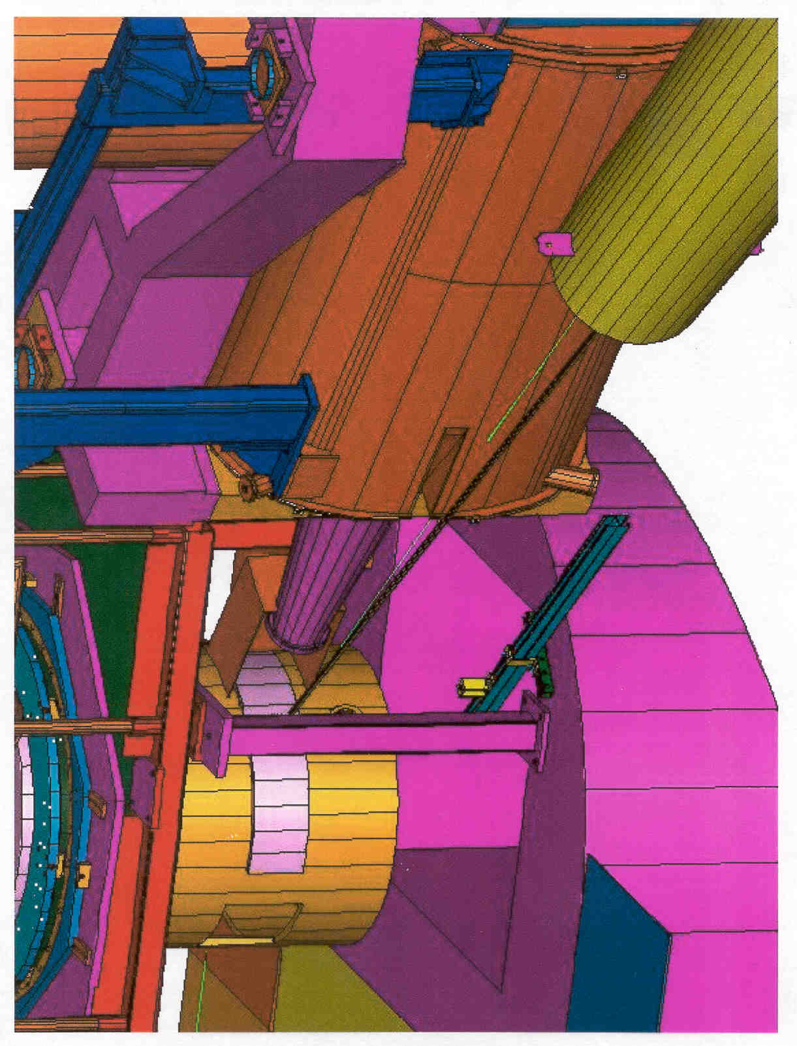

Pivot model with Polarized target and HMS Q1
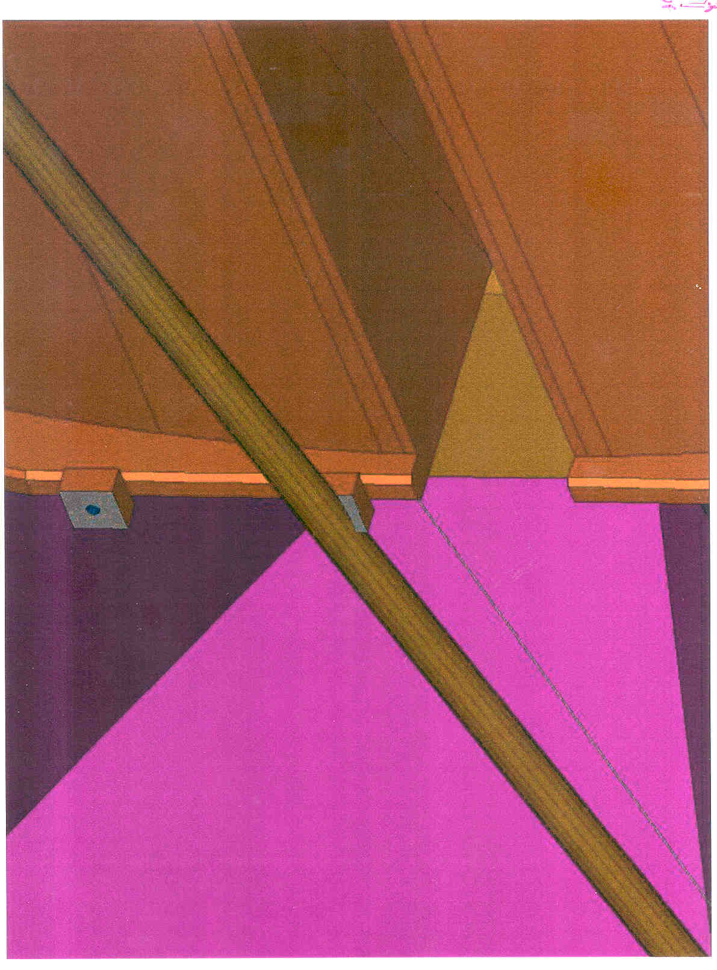

Deflected path of rastered beam past Q1
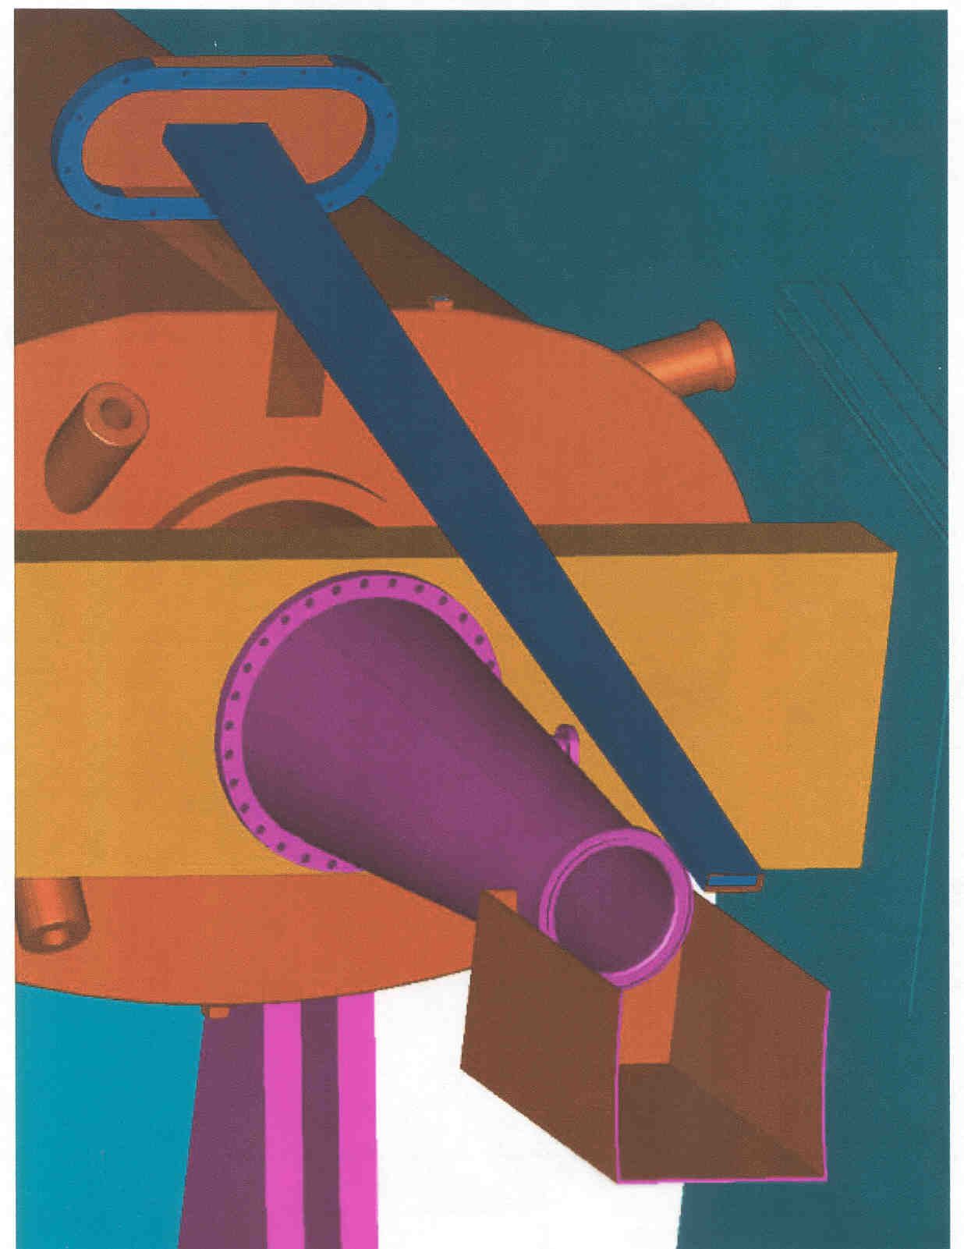

Beam duct past Q1 for E-01-006 experiment
A hydro-formed Aluminum HMS window

It is well known that dished heads have much higher pressure ratings than a same thickness flat head.
This is so because for a dished head the stress is

S = P * Rc /2t Ref. Roark and Young Ch. 12, Table 28 , case 3a

Where P is the pressure 14.7 Psi

Rc is the radius of curvature of the head 36.25 in.

T is the thickness 0.011 in.

Aluminum 2024 T3

Ultimate tensile strength 65 KSI

Yield strength 45 KSI

The stress of an HMS exit window dished head with an Rc of 36.25in. and thickness of 0.011 in

S= 14.7 * 36.25 / 2 / 0.011 = 24 KSI

Safety margins 24 KSI < 0.5 Tu = 0.5 * 65 = 32.5 KSI

24 KSI < 0.9 Ty = 0.9 * 45 = 40.5 KSI

Therefore meets the stress criteria of FNAL 1380 !

Factor of safety is Tu / S = 65 / 24 = 2.7 (assuming no further yielding)

Note: the Flange diameter is 36.62 so the head profile has Rc/D ~ 1.0 similar to so called ASME heads.

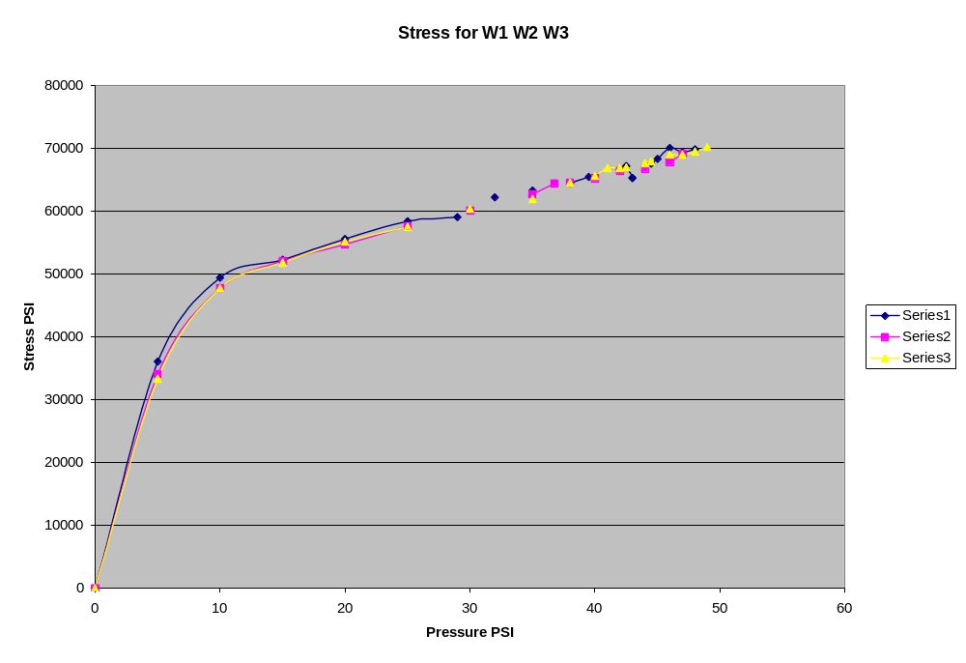
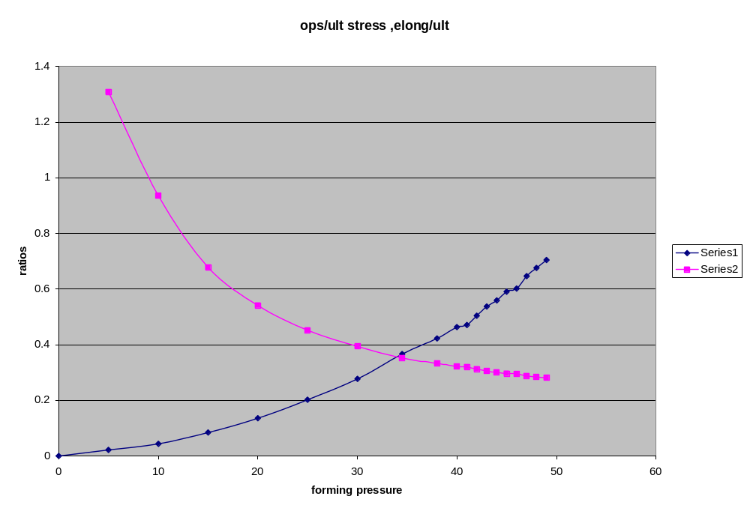

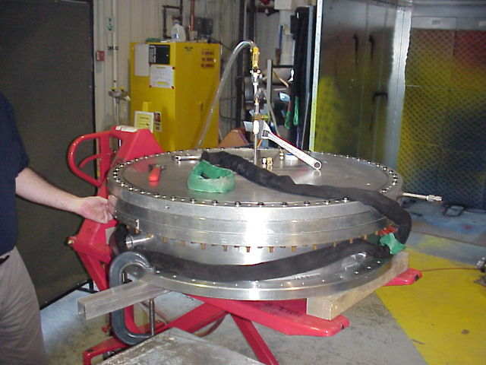

Hydro forming setup for production HMS Aluminum windows.
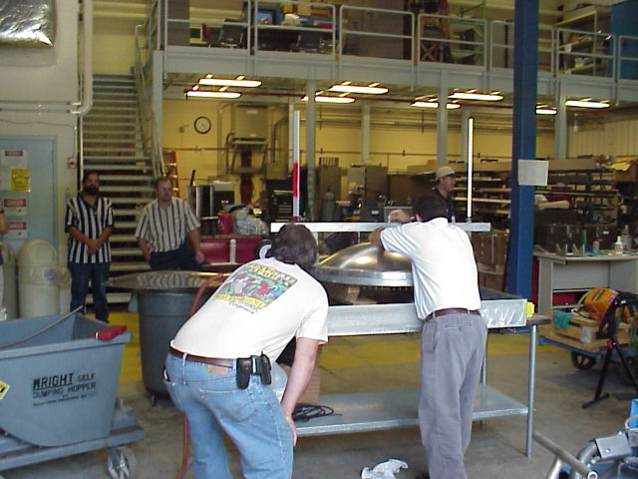

Technicians measuring curvature of hydro formed Aluminum window
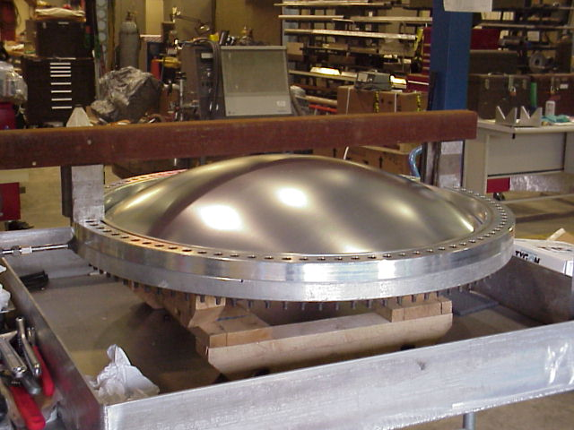

Hydro formed window during ultimate pressure test
HMS Exit Window

Material Alclad 2024

Thickness 0.011 in.

Water jet cut blank – hydro-formed “dished head”

Forming pressure is optimized

P(operating) =14.7

P(forming) = 28

P(ultimate) = 49

Relative Elongation (forming) = 0.37

Ultimate pressure test data

Test Ultimate Pressure

W1 49 +/- 1
W2 48 +/- 1
W3 50 +/- 1

Abuse tests !

Test A1
Spear test with 1000 gal tank AOK

Test A2
Drop tests “ Foreign Object Penetration “

Note: this window was slightly kinked during hydro-forming and would not have been used.

All object impacts below were in the SAME window!

1) ½ inch pipe fitting – small dent

2) 3/8 flathead bolt – small hole – tapped shut

3) KF 40 vacuum clamp – small dent

4) 9/16 open end wrench – tossed – small hole – tapped shut

5) 9/16 inch open end wrench – thrown with full force – window failed

Window tear from point of impact through the previous holes !!

Test A3

Repeat test with thrown object (the 9/16 wrench) on a new window – in progress

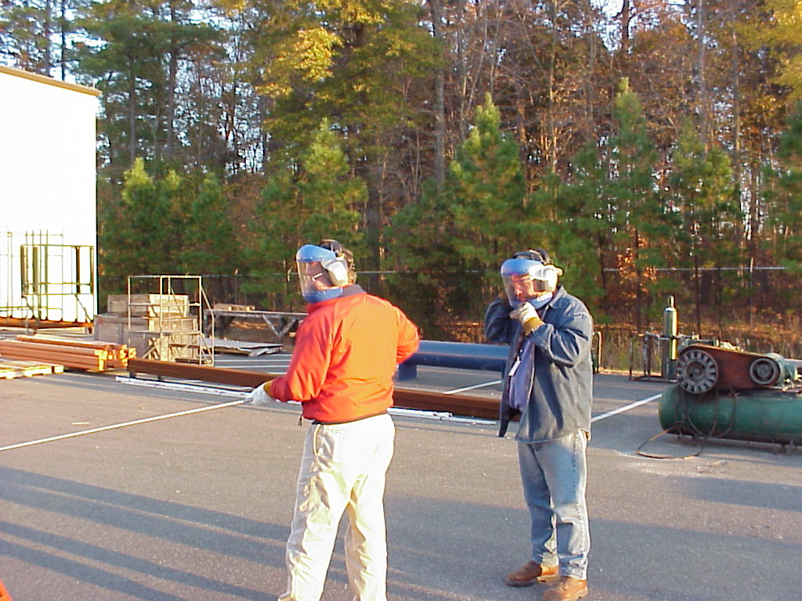

The Happy Spear Chucker!!
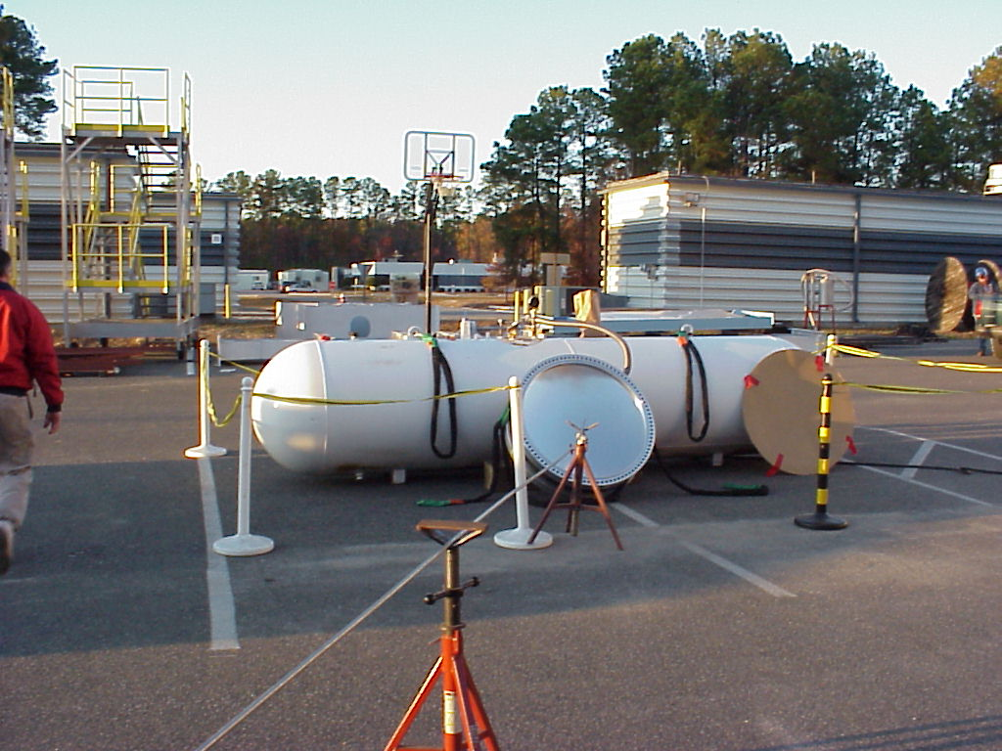

Spear test setup with 1000 gallon vacuum boost tank
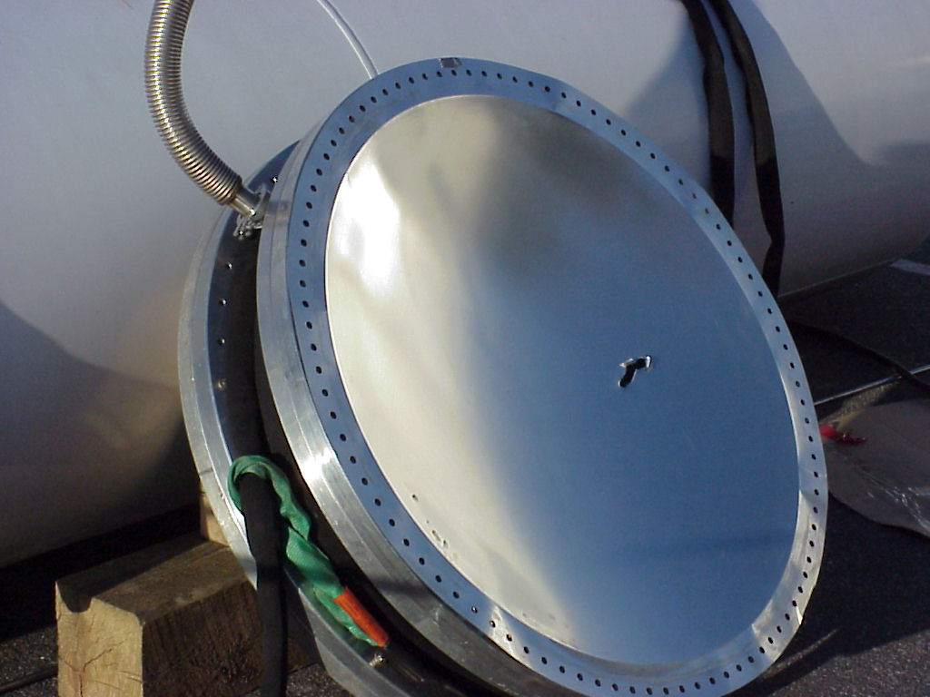

Gash from Spear test
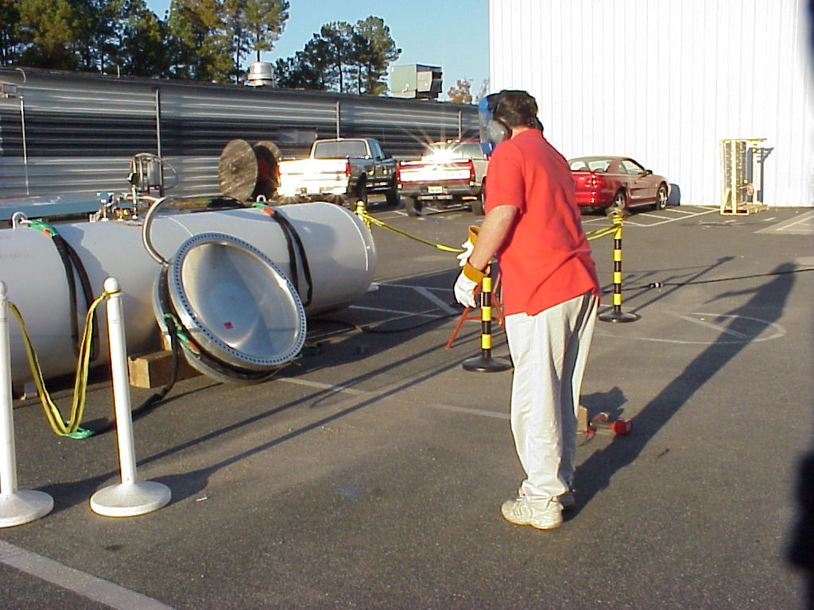
Throwing test objects at HMS Aluminum window
Note the red tape covering a hole made by the previous thrown object!!

