Introduction to Drell-Yan PT

Dynamical Nuclear Polarized Targets
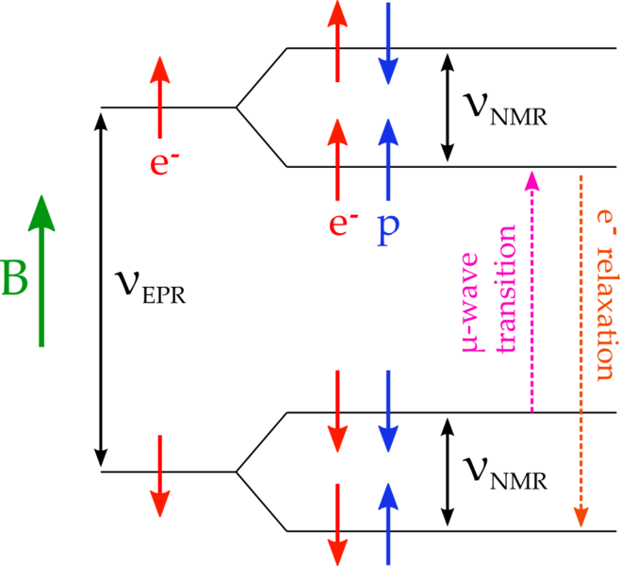
DNP or Dynamically Nuclear Polarization can be most easily understood by starting with the simplest example of a polarization mechanism which is the Solid Effect. Though the polarization dynamics tend to be a lot more complicated, for our purposes this works as a good instructional example. In the case of the proton we can expect to get better than 90% polarization using an irradiated NH₃ target sample where the irradiation has knocked out some amount of protons creating color centers leaving a paramagnetic complex in the sample. For optimal polarization this material spin-density needs to be just right for the magnetic field strength of 5T and temperature of around 1K. The basic operating principle involves using spin-spin coupling of the free electrons in the complex (which polarized readily in the magnetic field) to polarized the proton using DNP. In a magnetic field, spin-spin coupling results in hyper-fine splitting, as seen in the above diagram.

Using microwaves of wavelengths corresponding to the energy gaps seen in the diagram, transitions can be induced to flip the spin of the proton along with the spin of the electron. As shown, the (down,down) state can be flipped to the (up,up) aligned state using microwaves, but by changing the microwave frequency it is also possible to flip the (down,up) state to the (up,down) state, thereby allowing us to anti-align the proton without changing the magnetic field. Thus both positive and negative polarizations are available using the same field.

Since the relaxation time of the electron at 1K is on the order of milliseconds, compared to the proton's tens of minutes, the same electron can be used to polarize many protons. The proton polarization is transferred away from the immediate vicinity of the free electrons via spin diffusion.

Thermal Equilibrium Polarization

The thermal equilibrium polarization is the quintessential calibration tool for the NMR polarization measurements. The target material will polarize without DNP by simply placing it in a high magnetic field B and at low temperature T and waiting for the material to thermalize with the cryogenic environment that its contained in (about three times the relaxation rate T₁), we can expect from Boltzmann statistics that our polarization should be:
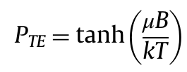
If we assume a 5T field and 1K temperature, comes out to a proton polarization of around 0.3%. We also note that the electrons, whose magnetic moment is 660 times that of the proton, have near 100% polarization. Being able to calculate the polarization for the thermally equalized system allows us to be able to calibrate the NMR system being that the NMR signal area is directly proportional to the area. A calibration is preformed by measuring the NMR area while in the thermal equilibrium so that we know the polarization of the sample at any NMR area.

A Closer Look at DNP
Enhancing proton polarization via the excitation of spin-spin transitions with microwaves is known as Dynamic Nuclear Polarization (DNP). There are 5 basic ingredients which go into this technique: a high magnetic field, a low temperature, a microwave system, an NMR system, and a suitable target material. We will briefly walk through these 5 building blocks, and what systems are necessary to provide them in the experimental hall.

Magnetic Field

The magnetic field is provided by a superconducting Helmholtz pair capable of producing 5T at great (10^-4) uniformity in a 3x3x3 cm^3 volume at the target cell. This magnet's open geometry allows for beam to pass at both parallel and perpendicular to the field. An Oxford Instruments power supply provides the necessary current (around 80A at 5T), and controls the modes of operation. During g2p, the magnet will be set at 5T or 2.5T. A reservoir of liquid helium at 4K keeps the magnet superconducting.

The two operating modes are ''connected'' and ''persistant''. A superconducting switch, which is simply a length of superconducting wire near a heater coil, changes these modes. In ''connected'', the switch is "opened" by heating the superconducting wire until it is resistive; this "connects" the magnet coils to the leads of the power supply connected on either side of the switch. In ''persistant'' mode, the switch is allowed to cool; as the wire again becomes superconducting, the relatively high resistance of the power supply leads makes it "invisible" to the current in the superconducting coils.

Magnet energization and de-energization may only be performed by a target expert. The ramp up and down must be carefully controlled to avoid losses in superconductivity called ''quenches''.

While "Magnet On" signs should make it clear, the large stray field of the magnet can be dangerous. Work in the hall should be carefully monitored, and the magnet may need to be ramped down. Safety first!

Shim Coils

The uniform field region can be tuned using a set of shim coils, but in practice this is not necessary. However, leaving the shim coils superconducting while the main coils are being energized will lead to trouble. Unless the shims are held at zero current by their power supply, the current induced from the main coil's energization can result in shim quenches in which too much shim current causes a failure in superconductivity.

Low Temperature: Cryogenics

The target's temperature directly affects the efficiency of polarization. The temperature's effects are easily seen in a graph of polarization over time. As inevitable beam trips occur, the polarization rises as the heat load of the beam is removed. When the beam comes back, the polarization drops a few percent simply due to the heat load. An example diagram of the pumps and fridge which create and maintain the low temperature is shown to the right, although the precise pumps used in the hall are slightly different.

The fridge, magnet, and liquid nitrogen shield are hung in the ''target can'' which is held at vacuum by a diff pump. The liquid nitrogen shield, seen in the diagram in green, protects the liquid helium components from heat radiation from the room temperature can.

You can follow the path of the cryogens in the diagram to the right. In the refrigerator, the ''separator pump'' pulls liquid helium from the magnet reservoir into the ''separator''. The separator can be thought of as a holding reservoir for colder liquid helium before it is transferred to the ''nose''. The nose is bottom of the fridge, where the target material is held. As liquid helium is transferred from the separator to the nose, it passes through heat exchangers which are cooled by evaporating helium being pumped out of the fridge. To maintain the low temperatures despite as much as 1W microwave and beam power dumped into the target, huge roots blower pumps work to maintain a low pressure in the refrigerator. These pumps pull the evaporated helium up, past the heat exchangers and baffles, and out of the fridge.

Maintaining the level of liquid helium in the nose is critical to the operation of the target, and monitoring this level is one of a target operator's tasks. The level of liquid helium must remain above that of the target cups or the polarization will be lost and the material may be melted by the beam. The liquid level should be adjusted automatically by a PID loop, but it's crucial to watch this level to ensure the loop is working.

These are the key indicators of the refrigerator to watch, and the two valves we use to control them during normal running:

- Main Flow: Indicates the flow of gas being pulled out of the nose of the fridge. This flow will indicate the heat load on the target in the form of boil off gas flow.
- Run Valve: Controls the flow of liquid helium from the separator into the nose, and therefore is used to maintain the level of liquid helium over the target cups.
- Nose Level: Indicates the level of liquid helium in the nose where the target cells are located
- Separator Flow: Flow of gas being pulled from the separator, which acts as a buffer of cold helium to send to the nose by pulling liquid helium from the magnet dewar.
- Separator Valve: Controls the separator flow, used to keep liquid helium in the separator.
- Separator Level: This indicated the level of liquid helium in the separator, most generally this should be consider full.

Microwaves

The microwaves induce the spin flip transitions and must be tuned very carefully to the frequency of the energy gap to maximize polarization. Unfortunately, as the target material accumulates radiation damage from the beam, this optimal frequency changes. '''The most important task of the target operators is to constantly monitor and tweak the microwave frequency to maximize polarization.'''

The microwaves are provided by the EIO tube, which allows the frequency of microwaves to be changed within limits by adjusting a bellows on the oscillation cavity. Wave guides carry the microwaves from the tube to a horn which shine on the target cups. The picture to the right shows the gold horn above (to the right of, here) the two target cups on the new target inserts.

In g2p, two magnetic field strengths (5T and 2.5T) will be used and thus two nominal microwave frequencies will be used (~140 and 70 GHz). This requires two different EIO tubes, but the operation will be similar.

Target Material

Choosing a target material is a compromise between our desire for a pure proton target, and the practical necessities of materials which perform well under DNP and heavy radiation damage. Ammonia and deuterated ammonia (14NH3 and 14ND3) have emerged as the most attractive materials for our uses. When doped with paramagnetic centers to provide free electrons for the spin-spin coupling, ammonia can achieve greater than 90% proton polarization.

To dope the ammonia with free electrons, it is irradiated in a smaller accelerator before it comes to JLab. This irradiation produces radicals such as NH2 from the NH3 in what is called a ''warm dose''. In the beam at JLab, temperatures are much lower, and different radicals, such as atomic H, are produced under this ''cold dose''.

Each target insert holds two cups with ammonia material samples. The cups are cylindrical, and roughly 1 inch in diameter and length. For g2p, the same microwave guide will be used for both top and bottom cups; the photo to the right shows the old insert cups from a previous experiment.

Anneals

The number of paramagnetic radicals in the material must be carefully balanced to achieve the greatest polarization. Although the free electrons from these paramagnetic centers are necessary to polarize via DNP, they also allow polarization decay short-cuts for the aligned protons. As radiation dose from the beam produces more radicals than needed, the DNP process becomes less efficient and the polarization will fall. However, by heating the ammonia, we can allow some of these radicals to recombine. This heating is called an ''anneal'', and for an experiment that runs at 80nA beam current, will likely be necessary every day. After an anneal, the polarization can again reach maximal levels.

There is a limit to the lifetime of the ammonia however. As successive anneals are performed on a material sample, the decay rate of the polarization will increase, requiring more anneals per day. This is due to the buildup of radicals which cannot be recombined in an anneal. Eventually, the polarization decay rate will be so fast that it is no longer practical to use the material, so a new ammonia sample will be used. This replacement of material will occur once a week.

NMR
[[Image:SignalDisplay.png|thumb|350px|NMR signal integration panel of the NMR control program. Here the polarization is positive and enhanced greatly. The first panel shows the raw signal in green and baseline in red. The second shows the baseline subtracted and polynomial fit, and the third panel shows the final NMR signal to be integrated.]]

The NMR system is used to measure the proton polarization in the sample, and operates by observing spin flips of the proton at its Larmor frequency. By embedding the inductor of an LCR circuit in the target material, we can detect energy lost or gained in the circuit as a function of the circuit's frequency. A loss of energy in the circuit near the proton's Larmor frequency would indicate the ''absorption'' of energy as its spin is flipped to be anti-aligned with the magnetic field. Likewise, a gain of energy in the circuit would come from a proton ''giving up'' energy as it becomes aligned. This gain or loss is visible as a dip or peak in the NMR signal versus frequency. The area under this dip or peak is a proportional measure of the proton polarization in the material.

Baselines
To accurately measure the area of the NMR signal's dip or peak which is due to the polarization of the proton, we must carefully exclude any systematic changes in the NMR signal which are not due to polarization. To do this, we take a ''baseline'' measurement of the circuit's response '''without''' the polarization signal. This can be achieved by shifting the Larmor frequency of the proton out of range of our signal by changing the magnetic field. The baseline NMR signal is very sensitive to minute changes in the NMR circuit, and it it important to make frequent baseline measurements to ensure an accurate polarization measurement. A baseline should be taken at least every day after an anneal.

In addition to subtracting the baseline signal, a polynomial fit is performed to ''wings'' the NMR signal. This polynomial fit subtraction should remove any residual baseline signal and leave only the signal due to the target polarization.

Thermal Equilibrium Measurements
To calibrate our polarization, we must discover the proportionality factor, or ''calibration constant'', which relates area under the NMR dip or peak to the proper polarization. To do this, we take advantage of the known polarization when the sample is at thermal equilibium. After forming the calibration constant using this static, known polarization and the measured NMR area, we can apply this constant when the target is being dynamically polarized with microwaves.

A thermal equilibrium measurement (or TE) requires removing the beam and the microwaves, setting the pressure and temperature in the nose to be as constant as possible, and waiting for the NMR area to stabilize. The relaxation time of the polarization depends on the temperature, so the temperature is raised above 1K to decrease the time spent waiting. Even so, this will likely take as much as an hour per cup. The number and quality of the thermal equilibrium measurements directly affects the error on the target polarization measurement, so the TE should not be rushed! In experimental circumstances, the pressure to hurry and get back to taking beam can result in sloppy TEs which adversely affect the experiment's systematic error. Take time to be accurate; time has been budgeted to allow for these TE measurements.

5T Magnet and Cryostat
Safety

Introduction
A Superconducting Magnet System can be operated easily and safely, provided the correct procedures are obeyed and certain precautions observed.
This safety section must be read and understood by everyone who comes into contact with a Superconducting Magnet System. They are NOT for the sole information of senior or specialist staff. Proper training procedures must be undertaken to familiarize effectively all persons concerned with such equipment with these requirements. Also since the field from the magnet is 3-dimensional, consideration must be given to floors above and below the magnet as well as the surrounding space on the same level.
The installation and operation of a Superconducting Magnet System presents a number of hazards of which all personnel must be aware. It is essential that:
- Areas in which magnet systems are worked on or used, and their installation generally, are planned with full consideration for safety.
- Such premises and installations are operated in a safe manner and in accordance with proper procedures.
- Adequate training is given to personnel.
- Clear notices are placed and maintained to effectively warn people that they are entering a hazardous area.
- All health and safety procedures are observed.
These notes outline aspects of operation and installation which are of particular importance, however, the recommendations given cannot cover every eventuality and if any doubt arises during the operation of the system, the user is strongly advised to contact the supplier.
It is the obligation of Oxford's customers to communicate effectively to their own customers and to users of the equipment in the information in this manual regarding safety procedures and hazards associated with magnet systems.
FLOOR LOADING
Professional assistance from a civil or structural engineer should be sought when considering any installation.

The Magnetic Field
Certain precautions must be taken to ensure that hazards will not exist due to the effect of a magnetic field on magnetic materials or on surgical implants. Typical of such effects are the following:
Large attractive forces may be exerted on equipment brought near to the magnet. The force may become large enough to move the equipment uncontrollably towards the magnet. Small pieces of equipment may therefore become projectiles, large equipment (e.g. gas bottles, power supplies) could cause bodies or limbs to become trapped between the equipment and the magnet. Either type of object may cause injury or death. The closer to the magnet, the larger the force. The larger the equipment mass, the larger the force.
The operation of medical implants, such as cardiac pacemakers, may be affected either by static or changing magnetic fields. Pacemakers do not all respond in the same way or at the same field level is exposed to fields above 5 Gauss.
Other medical implants, such as aneurysm clips, surgical slips, or prostheses, may contain ferromagnetic materials and therefore would be subject to strong forces near to the magnet. This could result in injury or death. Additionally, in the vicinity of rapidly changing fields (e.g. pulsed gradient fields), eddy currents may be induced in the implant resulting in heat generation.
The operation of equipment may be directly affected by the presence of large magnetic fields. Items such as watches, tape recorders, and cameras may be magnetized and irreparably damaged if exposed to fields above 10 Gauss. Information encoded magnetically on credit cards and magnetic tape including computer floppy disks, may be irreversibly corrupted. Electrical transformers may become magnetically saturated in fields above 50 Gauss. The safety characteristics of equipment may also be affected.
To prevent situations as described above from occurring, the following general precautions are provided as guidelines. These should be regarded as minimum requirements. Every magnet site location should be reviewed individually to determine precautions to be taken against the above hazards. Also, since the field from the magnet is 3-dimensional, consideration must be given to the floors above and below the magnet as well as the surrounding space on the same level.
Before ramping the magnet to field
The following precautions must be taken,
- Ensure all loose ferromagnetic objects are moved from within 2 meters of the OVC, or 3 meters for high field magnets ( > 11 Tesla).
- At all points of access to the magnet room display warning signs that the magnet is operating.
- Display warning signs giving notice of the possible presence of magnet fields and of the potential hazards in all areas where the field may exceed 5 Gauss.
- Ensure all electronics and interfacing equipment supplied by Oxford instruments are placed in areas where the field is less than 10 Gauss.
- The safe working field level of other equipment must be individually assessed by the system manufacturer.
After ramping the magnet to field
- Do not bring ferromagnetic objects into the magnet room.
- Use only non-magnetic cylinders and dewars for storage/transfer of compressed gas or cryogenic liquids. Equipment for transportation of cylinder/ dewars must be non-magnetic.

Fire and Explosion Hazards
In the case of fire evacuate personnel from the area and sound the fire alarm.
Water must not be used on electrical equipment and when sprayed on cryogenic liquids will rapidly freeze. The magnet ventilation may become blocked by ice with subsequent risk of explosion and the release of cryogens from the system.
The surface temperature of containers for liquid nitrogen and helium, if not vacuum insulated, may be sufficiently low to condense oxygen or oxygen enriched air. This liquid in contact with flammable substances can become explosive.
Portable fire fighting equipment must be non-magnetic and should be installed by agreement with the local fire authority.
Local emergency services must be informed of the presence of a magnet operating in their area as this may affect their procedures in dealing with fires or other accidents.
In case of a large cryogen spillage avoid direct contact with the liquid; sound fire alarm and evacuate the area.
Oil mist filters should be fitted to pumps to reduce the emission of toxic oil vapors which pose both health and explosion hazards.

The Safe Handling of Cryogenic Substances
Cryogenic liquids can be handled easily and safely provided certain precautions are obeyed. The recommendations in this section are by no means exhaustive and when in doubt, the user is advised to consult the supplier.
They safe handling of cryogenic liquids requires a knowledge of the properties of these liquids, common sense, and sufficient understanding to predict the future behavior of such liquids under certain physical conditions.
The substances referred to in these recommendations are nitrogen, air, and helium.

General Safety Rules
Cryogenic liquids, even when kept in insulated storage vessels (dewars), remain at a constant temperature at their respective boiling points and will gradually evaporate. The very large increase in volume accompanying this vaporization is approximately 700:1 for helium and nitrogen and therefore:
CONTAINERS OF CRYOGENIC LIQUIDS MUST NOT BE COMPLETELY CLOSED AS THIS WOULD RESULT IN A LARGE BUILD UP IN PRESSURE AND THUS PRESENT AN EXPLOSION HAZARD. The nitrogen jackets is always fitted with a non-removable overpressure valve, the OVC is fitted with a combined overpressure / evacuation valve, and the helium bath must have the large black and red quench valve fitted. (This is normally supplied in the spares kit or left attached to the helium exit port).
In the event of a large spillage operate the fire alarm and evacuate the area.

Health Hazards
Asphyxia of varying severity will occur if the magnet room is not properly ventilated. (Helium can displace air from the top of a room and cold nitrogen can displace air from lower levels).
Burns. Cryogenic substances in liquid or vapor form or as low temperature gases produce effects on the skin similar to burns (cold burns).
Exposed or insufficiently protected parts of the body coming into contact with uninsulated venting pipes or vessels (see ventilation section) will stick fast and the flesh will be torn if removed.

First Aid
If any of the cryogenic liquids come into contact with eyes or skin, immediately flood the affected area with large quantities of cold or lukewarm water and then apply cold compresses. NEVER use hot water or dry heat. MEDICAL ADVICE SHOULD BE SOUGHT IMMEDIATELY.

Protective Clothing
Protective clothing must be worn mainly to avoid cold burns and dry leather or PVC gloves must be worn when handling or working with cryogenic liquids. Gloves must be loose fitting so that they can be removed easily in case of liquid spillage. Eyes must be protected by goggles. Do not wear any metallic objects (e.g. jewelry) on those parts of the body where they may come into contact with the liquid.

Handling
Cryogenic liquids must be handled and stored in well ventilated areas.
Do not allow cryogens to come into contact with the body.
Always handle the liquids carefully - boiling and splashing will always occur when filling a warm container or when inserting warm objects into the liquid. When inserting open ended pipes into the liquid, block off the warm end until the cold end has cooled down (otherwise cold liquid may spurt out of the open end under self-generated pressure). Never direct pipe/piping towards any person.
Beware of liquid splashing and rapid flash-off of helium when lowering equipment at ambient temperature into liquid. This operation must be carried out very slowly.
Use only metal tubing connected by flexible metal hose for transferring liquid nitrogen. For the coupling DO NOT use rubber tube, silicon rubber tube (including hospital grade tube - this explodes!), or plastic tubing e.g. garden hose and including reinforced tubes e.g. for air lines - this shatters unexpectedly and may cause injury to personnel. It should be noted that polythene and nylon lines are sometimes used, however, this should not be taken as an implied recommendation, all lines should be tested in safe circumstances or used only after the manufacturer's recommendation.

Equipment
Only use containers specifically designed for use with particular cryogens and constructed of non-magnetic materials.

Liquid Nitrogen
Good ventilation is essential.
Store and use in a well ventilated place. If enough gas evaporates from the liquid in an unventilated place (e.g. overnight in a closed room) the oxygen concentration in the air may become dangerously low. Unconsciousness may result suddenly without previous warning symptoms and may be fatal. For example, the evaporation of 25 liters of liquid nitrogen produces 17,000 liters of nitrogen gas (600 cu. ft.). If this vaporization takes place in a room of 54 m³ (2,000 cu. ft.), i.e. 3 x 6 x 3 meters high (10 x 20 x 10 feet high) it can produce a very dangerous situation if the room is not ventilated. Appropriate multiplication of these parameters will indicate actual site conditions.
Minimize contact with air
Since liquid nitrogen is colder than liquid oxygen, the oxygen of the air will condense into the nitrogen and if allowed to continue for some time, the oxygen concentration may become so high that the liquid may become as dangerous to handle as liquid oxygen. This applies particularly to wide-necked dewars. Therefore ensure that contact with air is kept to a minimum.
Do not smoke (not just in the context of this manual. It's really bad for you.)
Rooms in which cryogenic liquids are being handled should be designated no smoking areas. While nitrogen and helium do not support combustion, their extreme cold can cause oxygen from the air to condense on cold surfaces and may increase the oxygen concentration locally. There is a particular fire danger if the cold surfaces are covered with oil or grease which is itself combustible.

Liquid Helium
Liquid helium is the coldest of all cryogenic liquids. It will therefore condense and solidify any other gas (air) coming into contact with it, with the consequent danger that pipes and vents may become blocked.
Liquid helium must be kept in specially designed, storage or transport dewars. Dewars should have a non-return valve fitted in the helium neck at all times in order to avoid air entering the neck and plugging it with ice. Vacuum insulated pipes should be used for liquid transfer; breakdown of the insulation may give rise to condensation of oxygen.

Ventilation of Exhaust Gases
Gaseous nitrogen and helium exhausted from the cryostat will displace oxygen and if not properly ventilated, the possibility of asphyxiation exists.
Cryogenic substances in liquid, or vapor form, or as low temperature gases, produce effects on the skin similar to burns (cold burns).
Exposed or insufficiently protected parts of the body coming into contact with uninsulated venting pipes or vessels will stick fast and the flesh may be torn if removed.
Exhaust systems are required in order to vent to atmosphere any discharge from the system cryostat as described below.
The static helium evaporation exits from the turret via a non-return valve. The valve prevents ambient air leaking back into the cryostat. The outlet from this valve should be vented out of the room to atmosphere or, if required, to a helium recovery system. In the event of a quench, the evaporated helium will be exhausted from the manifold via the pressure relief valve(s). The amount of gas is dependent on the type of system, but for a 500MHz NMR magnet quenching with 100% helium, the volume of gas at room temperature will be approximately 50,000 liters. If the system is located in a small room then a system should be provided that is capable of exhausting this gas to the atmosphere or to a recovery system.
The static nitrogen evaporation will exit from one (or two) of the nitrogen ports. This gas should be vented out of the room to atmosphere.

Environmental Safety
It is the responsibility of the user to ensure that all equipment, services, data links, or personnel passing through the affected space are adequately protected and that access to the area is controlled. Access doors leading into the affected areas must be capable of being secured against unauthorized entry and fitted with warning signs. It is also recommended that local barriers be erected around the magnet and be fitted with warning signs. Care must be taken to advise personnel who have access (in particular security or cleaning staff who often have their own keys) of all the risks associated with magnetic fields and systems operating with cryogens.

Description and Operation of the System

General Description
This system comprises a special horizontal field 5T split pair magnet mounted in the tail section of a large capacity, liquid nitrogen shielded, vacuum insulated cryostat. The magnet has a cold split of 100 mm x 40 mm and a cold bore diameter of approximately 120 mm, accessed through aluminium windows. Alternatively, room temperature tubes may be inserted to allow the magnetic field to be plotted. The vertical split access allows a large cooling power helium-4 insert to be fitted from above.
The cryogenic efficiency of the cryostat is very high due to the small helium neck diameters and the way in which the exhausting helium gas is used to cool them. The helium can heat load is minimized by the use of a nitrogen cooled shield which will minimize both the conducted and radiated heat to the minimum levels possible.
The current leads are all fixed for high reliability and safe operation.
The magnet is 5 T with a homogeneity of better than 1 in 10⁻⁴ over a length of 20 mm and a diameter of 80 mm. See the (insert link to Test Results) for more detailed information. Access is provided through aluminium windows which may be demounted if required for access to the magnet cold bore.
The weight of the system is approximately 1,000 kg. Appropriate lifting gear must be used to move the cryostat.
This system, when energized to full field has a considerable stray field, extending over many meters, and the system stored energy is approximately 0.5 MJ. It is therefore VITAL that the safety section is read by ALL personnel coming near the system.
PARTICULAR CARE MUST BE TAKEN TO ENSURE THAT THE SYSTEM IS WELL ANCHORED TO THE FLOOR, AND ANY STEEL OBJECTS IN THE VICINITY ARE SIMILARLY WELL BOLTED TO THE FLOOR.

Cryostat Description
The cryostat is of a vacuum insulated, all metal construction with intermediate temperature radiation shielding. The outside surfaces of the helium and nitrogen vessels are wrapped with single or multi-layer super-insulation to reduce emissivity. The outer vacuum case (OVC) of the dewar will be fitted with an evacuation valve incorporating a pressure relief safety feature that will operate in the event of a cryogen leak to the vacuum space. In addition there is a drop-off plate at the base or side of the dewar.
The siphon entry port has an associated cone located within the cryostat. A tube runs from the cone to the bottom of the cryostat and ensures that all liquid nitrogen can be removed from the helium reservoir after pre-cooling the magnet and that filling with helium is from the bottom.
All cryomagnet service ports should be sealed with the plugs provided when not in use. In all cases, the boil-off of cryogens is minimized by taking great care in the design to prevent heat entering from the following main sources:
Gaseous conduction. An evacuation / pressure relief valve allows the insulating vacuum space to be evacuated to less than 10⁻⁴ torr.
Metallic conduction.Great care is always taken to use materials of low thermal conductivity combined with mechanical strength to support the cryogens in their vacuum. The supports (usually tubes) are of minimum cross sectional area and maximum effective length within overall size constraints. Neck tubes are thermally anchored with a copper thermal link to the top of the nitrogen vessel and good use is made of the enthalpy of the exhausting gas to minimize incoming conducted heat.
Radiation. The radiation load is reduced to reasonable values by the introduction of intermediate temperature radiation shields. These are usually cooled by a reservoir of liquid nitrogen surrounding the helium bath. The enthalpy of the exhausting helium gas is sometimes used to cool a radiation shield inside the nitrogen shield. The emissivity of cold surfaces can also be reduced. This is achieved using many interleaved layers of aluminium and insulation known as super-insulation.
Ohmic heating. The principal sources of ohmic heating are the current leads and the superconducting switch. In some systems the current leads are made demountable to minimize the cryogen boil-off with a persistent magnet, the remainder of systems feature carefully designed current leads which do not impose a significant heat load. All systems now feature low-loss switches.

Evacuating the Cryostat OVC
In order to maintain the thermal isolation of the liquid helium it is necessary that a high vacuum be maintained within the cryostat outer vacuum case.
IMPORTANT In many cases the thin wall construction of the helium reservoir will not support an external pressure differential of one atmosphere. The helium reservoir must therefore NEVER be evacuated unless the OVC is first evacuated. The recommended pumping equipment consists of an oil diffusion pump of 50 mm (2 inch) diameter or, even better, a turbomolecular pump fitted with a liquid nitrogen cold trap. This pump should be backed by a rotary pump of not less than 12-15 m³/hr pumping speed, fitted with a gas ballast facility. All connecting lines should have an internal diameter of not less than 50 mm and be as short as possible. Tubes must NOT have been used previously to carry or pump helium.
a. Connect the valve on the cryostat top flange to the pumping equipment. Using the rotary pump, evacuate the cryostat slowly (approximately half hour) to prevent any possible collapse of internal shielding, until the pressure is less than 0.05 mbar.
b. Switch over to the diffusion pump and evacuate the cryostat to less than 5 x 10⁻⁴ mbar. Continue pumping at least overnight to ensure the removal of residual gases trapped in the super-insulation.
Inspecting the vacuum:-
If the cryostat is already evacuated and it is desired to inspect the pressure only, the pumping tube should be evacuated and the diffusion pump operating before the OVC valve is opened. If the pressure is greater than 10⁻³ mbar with the system warm, the cryostat should be evacuated overnight with the diffusion pump to less than 5 x 10⁻⁴ mbar. It is recommended that the cryostat is always pumped overnight before use.
Flushing the vacuum space:-
If the vacuum space has been accidentally contaminated with helium gas or moisture evacuation can be improved by flushing the space. NOTE: Never vent cryostats with helium gas as this will 'stick' in the super-insulation.
- Using a rotary pump, evacuate cryostats to less than 1 mbar.
- Admit an atmosphere of DRY nitrogen gas, preferably through a 1 mm orifice, and pump out to less than 1 mbar.
- Repeat (2) several times, then pump to less than 0.05 mbar.
- Switch over to the diffusion pump as in (b) above.

Precooling the Magnet
Before filling the cryostat with liquid helium, the magnet and system must be cooled to a temperature below 100 K, this will save a considerable amount of liquid helium which is much more expensive than liquid nitrogen. To perform the precool, fill the liquid helium container with liquid nitrogen, completely above the magnet. Use a length of 9.6 mm diameter stainless steel tubing inserted into the transfer tube entry port (this is the 'blow-out' tube supplied with the system). Ensure that the tube is located in the cone fitting below the siphon entry port inside the cryostat, the liquid nitrogen storage dewar should be conveniently positioned and connected to the blow-out tube with flexible plastic tubing (once the transfer has started this should not be moved as it is very brittle and will break easily). Allow the liquid nitrogen to remain for one or two hours and then fill it completely again.
The liquid nitrogen should then be removed. Insert the stainless steel tube into the transfer entry fitting and ensure that it is firmly fitted into the cone on the top of the magnet. Blow out all the liquid nitrogen by pressurizing the liquid helium container with helium gas to not more than 0.25 atmospheres overpressure, the blown out liquid nitrogen may then be usefully fed into the nitrogen can, see Filling the Liquid Nitrogen Container (the next section). Do not stop this prematurely as removing the remaining nitrogen could cause problems. Use the heaters on the helium can to remove the last few liters of liquid nitrogen that will be left in the helium can. Monitor the background in the OVC with a leak detector connected to the OVC pumping line to check for low temperature leaks from the main bath to the OVC. It is important that all the liquid nitrogen is removed. Failure to do this properly will make filling with the liquid helium difficult, and may impair the performance of the magnet. When all the nitrogen has been removed, release the pressure in the liquid helium bath and evacuate the liquid helium container using a rotary pump and then fill it with helium gas. If during pump down, a pause is seen in the range of 70-100 mbar, and the pumping line becomes very cold, then liquid nitrogen is still present. Stop pumping immediately and flush out the helium bath with helium gas fed down the blow out tube (which should be located in the cone fitting). Failure to do this will result in solidification of the nitrogen. Repeat this procedure at least two times in order to thoroughly purge the magnet of nitrogen. As an indication that all the liquid nitrogen has been removed, check that it is possible to evacuate the liquid helium container to a pressure less than 10 mbar.

Allen-Bradley and Rhodium-Iron Sensor Characteristics
Please not that this table is a guide for cooldown monitoring purposes only, and is not a substitute for a full calibration.
Temperature  (Kelvin) | Allen-Bradley Resistance / Ω |  | 27 Ω Rhodium Iron  sensor  Resistance / Ω
Temperature  (Kelvin) | 100 Ω sensor | 270 Ω sensor | 27 Ω Rhodium Iron  sensor  Resistance / Ω
500 | - | - | 51.4
475 | - | - | 48.2
425 | - | - | 42.8
373 | - | - | 37.5
323 | - | - | 32.2
300 | 100 | 270 | 29.8
260 | 101 | 276 | 25.7
220 | 103 | 285 | 21.73
180 | 105 | 296 | 17.66
160 | 107 | 304 | 15.87
140 | 109 | 314 | 13.46
120 | 112 | 326 | 11.38
100 | 116 | 343 | 9.2
90 | 118 | 354 | 8.18
80 | 122 | 367 | 7.19
75 | 124 | 375 | 6.72
70 | 126 | 384 | 6.27
60 | 131 | 407 | 5.43
50 | 140 | 435 | 4.73
40 | 150 | 485 | 3.75
30 | 170 | 560 | 3.36
20 | 210 | 730 | 3.18
16 | 241 | 860 | 2.95
12 | 300 | 1120 | 2.81
10 | 350 | 1350 | 2.65
8 | 440 | 1770 | 2.45
6 | 625 | 2700 | 2.28
4.5 | 950 | 4500 | 2.25
4.2 | 1050 | 5000 | 2.22
4 | 1150 | 5500 | 2.16
3.5 | 1500 | 7100 | -
3 | 2100 | 10000 | -
2.8 | 2400 | 12300 | -
2.6 | 2950 | 15000 | -
2.4 | 3500 | 19500 | -
2.2 | 4400 | 25500 | -
2 | 5650 | 35000 | -
1.9 | 6800 | 41000 | -
1.8 | 8000 | 49000 | -
1.7 | 10000 | 60000 | -
1.6 | 12400 | 83000 | -
1.55 | 14000 | 100000 | -
Approximate % error due to magnetic fields:
Sensor | Allen-Bradley Resistor |  |  | Rhodium-Iron Resistor
Field | 2.5 T | 8 T | 14 T | 1 T | 3 T
2 K | 0.5 | 1.5 | 4 | 0.13 | 0.88
4.2 K | 0.5 | 3 | 6 | 0.13 | 0.79
50 K | - | - | - | 0.14 | 0.84
77 K | 0.1 | 0.5 | 1.5 | - | -

Filling the Liquid Nitrogen Container
In the interests of economy it is advisable to precool the magnet before filling the nitrogen can. The procedure for this is described previously and will ensure that the cryogens are most efficiently used.
Connect one of the three filler / vent tubes of the liquid nitrogen container to a storage vessel using flexible polythene pipe. Transfer the liquid nitrogen by pressurizing the storage vessel to approximately 0.25 atmospheres above atmospheric pressure. Violent boiling will occur initially until the radiation shield has cooled down. When liquid nitrogen sprays out of the filler tubes release the pressure on the storage vessel to stop the transfer.
The storage vessel can be pressurized using a valve on the outlet. By using an electronically controlled valve, the liquid nitrogen container can be filled and the level maintained using a Liquid Nitrogen Level Controller. Inspect the liquid nitrogen at intervals appropriate to the overall system hold time.
All Oxford Instruments cryostats are fitted with overpressure relief valves which are not customer removable. The problems caused by ice formation in the filling tubes can be reduced by slipping 0.25 m lengths of plastic tubing over them. These tubes also prevent any overflow of liquid nitrogen from cooling the top flange and its 'O' ring. This can be important if an autofilling system fails to stop the nitrogen transfer when the tank is full.

Transfer Tube and Storage Dewar Adapter for Liquid Helium
The transfer tube optionally provided with the system is of a stainless steel construction. It takes the form of a tube surrounded by a second tube with a vacuum of better than 10⁻⁴ mbar maintained between them. The assembly of the two tubes usually takes the form of a large 'n' shape.
Occasionally re-pumping of the tube will be necessary in service, particularly during the first few months while the materials in the tube are still outgassing.

The ST9 Siphon Evacuation Fitting
The transfer siphons supplied by Oxford Instruments are supplied pre-evacuated, however re-evacuation may become necessary after a period of operation. To evacuate an Oxford Instruments standard siphon, an ST9 fitting is needed to operate the vacuum valve.
- Remove the yellow nylon dust cap from the transfer tube valve. Connect the ST9 fitting to the high vacuum pumping system.
- Place the ST9 fitting over the transfer tube valve. Evacuate the pumping lines and check the system for leaks.
- Using the red anodized aluminium knob, which is connected to the hexagonal key internally, open the transfer tube valve. Pump out the siphon to 10⁻⁴ mbar or better.
- Close the transfer tube valve using the red knob, isolate the pump and remove the ST9.
- Replace the dust cap.
- Try to avoid getting dirt in the ST9 fitting.
Note: The cryostat overpressure relief valve must be in position and not restricted. If the cryostat is connected to a recovery system any flow meter should be capable of high flow rates and should not introduce a restriction (it may be sensible to fit a bypass flap valve to accommodate the high flows during a possible quench, ensuring that all the helium is recovered).

Initial Filling with Liquid Helium
- Check that the transfer tube has the correct leg lengths and diameters to be compatible with the cryostat and storage dewar. Connect the cryostat and storage dewar to the helium recovery system or put a one-way valve on the cryostat exhaust port (if the system is large and a one-way valve is found too restrictive, it may be replaced by a 2 m length of convoluted tubing). Position the liquid helium storage vessel so that the transfer tube can be inserted easily and is close to the cryostat to be filled.
- Remove the plug from the cryostat transfer tube entry port and also from the top of the storage vessel. Insert the transfer tube legs into the cryostat and, slowly, into the storage dewar, allowing it to cool gradually. Ensure that the end of the transfer tube in the cryostat is fitted into the cone on top of the magnet. In this way, cold gas and then liquid is introduced at the bottom of the magnet which is then cooled by the enthalpy of the gas as well as by the latent heat of evaporation.
- Start transferring the liquid helium by pressurizing the storage vessel. (This is generally done by gently squeezing a rubber bladder). The transfer rate should be such that the vent pipe is frozen for not more than 2 m of its length. The initial transfer rate should be equivalent to about 10 liters of liquid per hour. This rate can be increased as the magnet cools and the boil-off reduces. Typically the cool-down from 77 K to 4.2 K will take between 10 and 60 liters depending on the system size and the care taken in the transfer.
By monitoring the Allen-Bradley sensors, when the magnet temperature falls below 10 K, the transfer rate can be further increased in order to fill the liquid helium container. This should occur when a further 10 to 50 liters of liquid have been transferred, depending on the size of the magnet and dewar.
4. When the liquid helium reservoir has been filled, stop the transfer by releasing the pressure in the storage vessel. Remove the transfer tube and replace the plug. Inspect the liquid helium level at appropriate intervals.

Refilling with Liquid Helium

High Cooling Evaporating Helium Refrigerator
Introduction
This high cooling power ⁴He refrigerator is designed to run at temperatures close to 1 K, and to give exceptionally high cooling powers.
Liquid ⁴He is fed to the insert from the main reservoir of the magnet cryostat in which it is mounted, through a vacuum insulated transfer tube. The liquid and gas are separated and the gas passes out of the insert through the exhaust tube which is soldered to the upper baffle set. The liquid passes through one of two needle valves (the run valve or the by-pass valve) into the sample space. If the run valve is used, the liquid first passes through a low temperature heat
exchanger, which is designed to cool the liquid to a temperature close to 1K before it is expanded through the needle valve, thus reducing the flash evaporation at the needle valve.
The insert is based on a well tried and tested design, and full running instructions are not given because the system is a copy of several others which have already been run by the users. The wiring information and the details of the tests at Oxford are included on the following pages. A full set of drawings is provided.
Wiring information
The wiring on the refrigerator insert is connected to the 18 way Fischer connector (item 6 on drawing no. AEA0436).
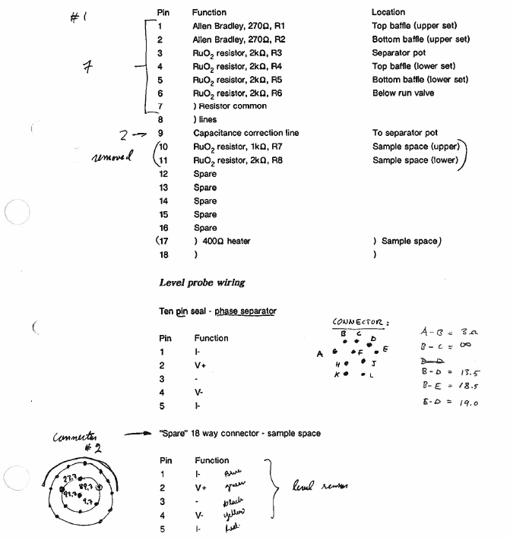
Test results
The insert has been tested in a standard bucket dewar, and for the purposes of this test an aluminium foil shield has been taped to the neck of the pumping line to act as a radiation shield. The liquid nitrogen vessel of the dewar was filed to give the insert a 77 K shield. This was the closest available approximation to the environment in which the insert will be running. In fact when the insert is run in the dewar it will be surrounded by the liquid helium can, so the radiated heat load on the insert will be rather lower than in the test dewar. The largest pumps available were a Leybold WS1001 roots pump, backed by a W$251 and an $65B rotary pump. The total pumping speed of this set, (through a 4 inch diameter, 1 metre long pumping line) was calculated to be approximately 800 m³/h.
The insert was filled with liquid helium and cooled to base temperature in single shot mode. This enabled us to determine the base heat load on the sample space by measuring the boil off. The boil off is approximately 110 cm³/h, corresponding to a heat load of approximately 80 mW. The heat load was subsequently reduced by improving the insulating vacuum.
The boil off from the separator pot appeared to be rather high, but the pot was filled and the siphon was quickly removed to allow the boil off of the pot to be measured. This was found to be approximately 0.45 l/hour, indicating that the long transfer siphon used to reach the transport dewar was rather lossy, and this loss has to be accepted for the tests. The system siphon is very much shorter and will have a lower loss.
The base temperature in single shot mode was measured by resistance thermometer and by the vapour pressure. A Leybold Thermovac gauge is used for the latter, and the accuracy is normally found to be quite good. The accuracy of the pressure gauge was checked against a McLeod type gauge at base temperature, at it agreed within 0.01 mbar. At base temperature, the RuO₂, resistors in the tail had resistances of 2040 and 2080 ohms. The pressure reading on the vapour pressure line was the same as that measured on the top of the insert, (using the same gauge), indicating that there was no measurable pressure drop in the line at this low flow. The vapour pressure (0.10 to 0.13 mbar) corresponds to a temperature of approximately 0.96 to 0.98 K. This flow rate and pressure at the top of the insert is consistent with a pumping speed of 825 m³/h. This also implies that if the 6000 m³/h pump at Michegan is used on the insert, the pressure at the top of the insert will be reduced to 0.014 mbar, corresponding to a temperature well below 0.9 K even if the base heat load was as high in the system.
A range of measurements was made with the insert in continuous fill mode, and the results are summarised in the tables below.
Thermometer readings during the test
The resistors are labelled R1 to R8 as marked on the previous page. The vapour pressure was measured either through the vapour pressure fine, P1, (which is terminated in the sample space) or at the top of the insert pumping line, P2.
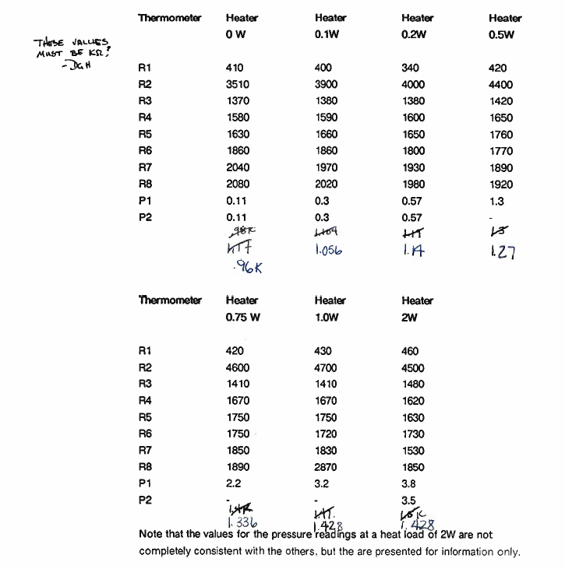

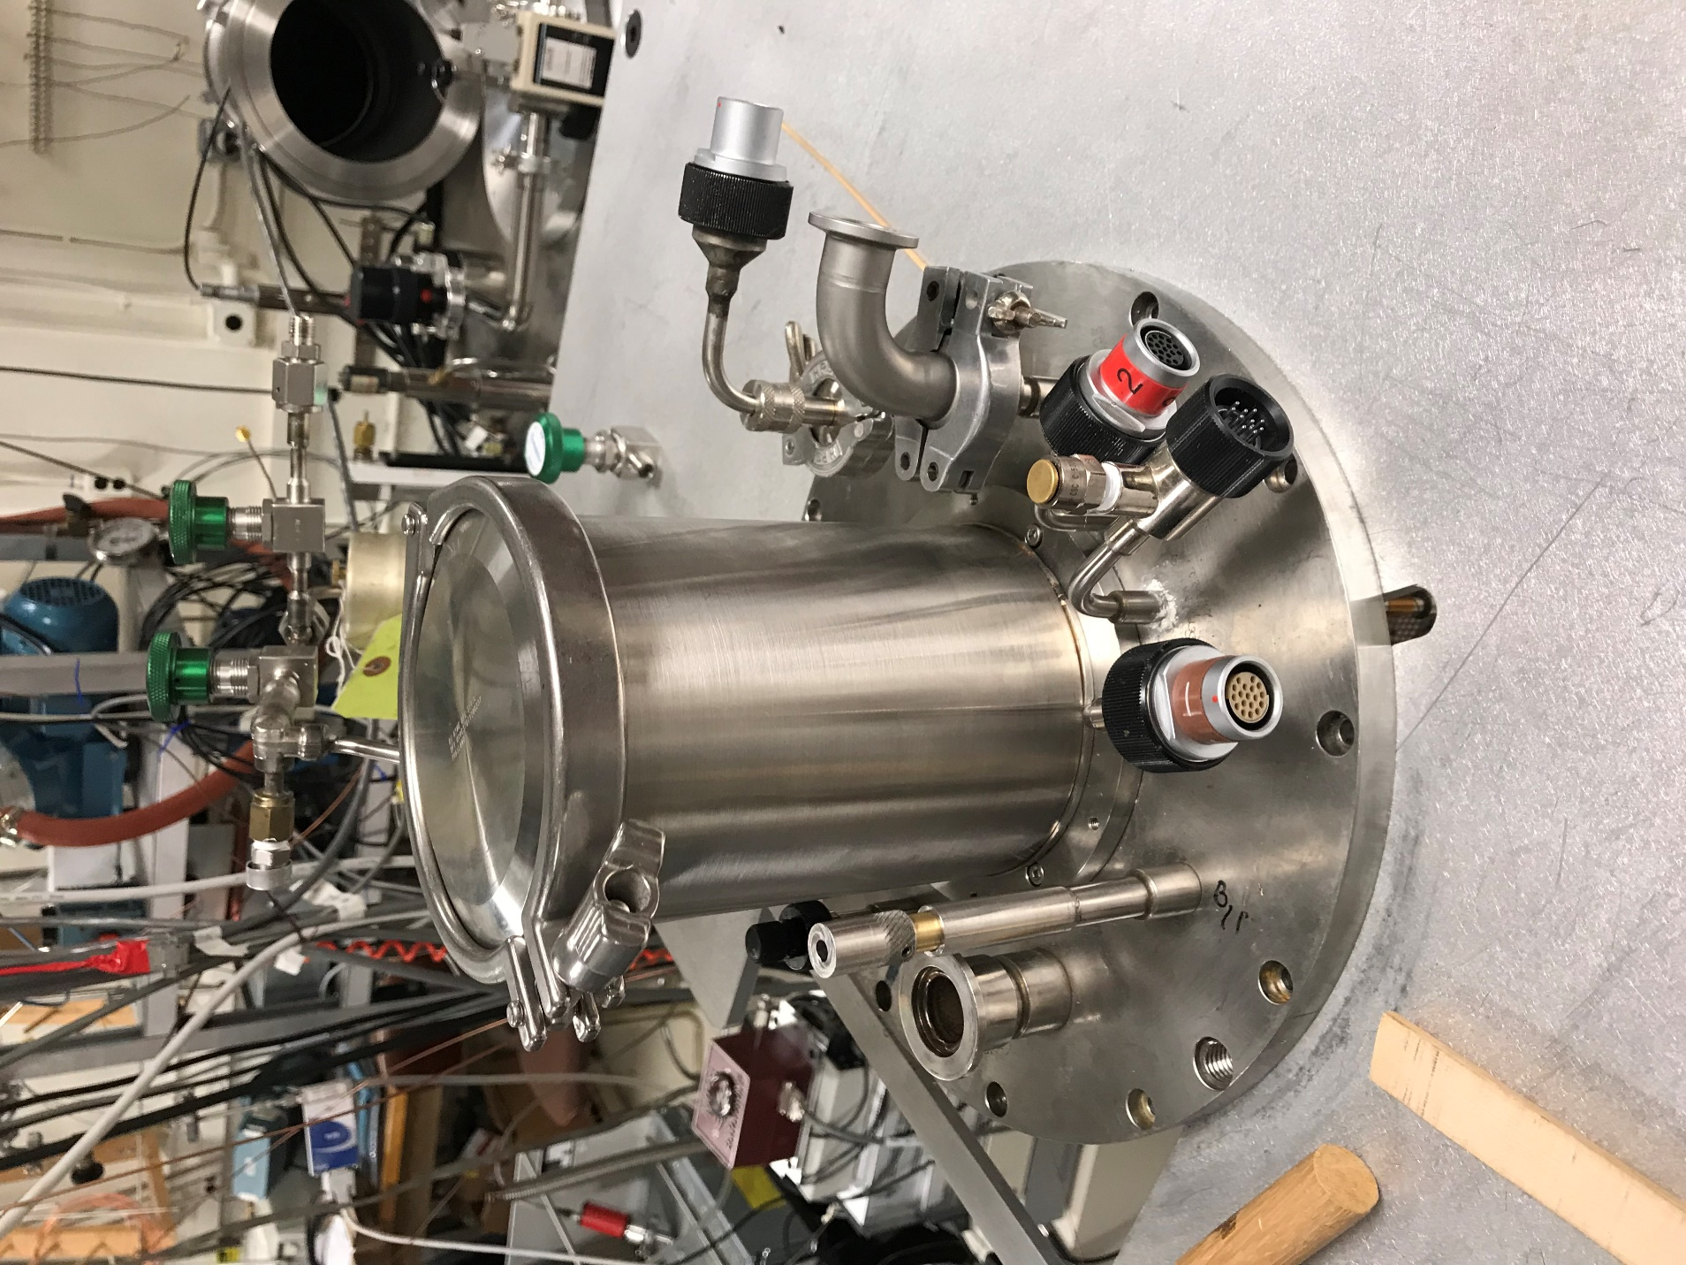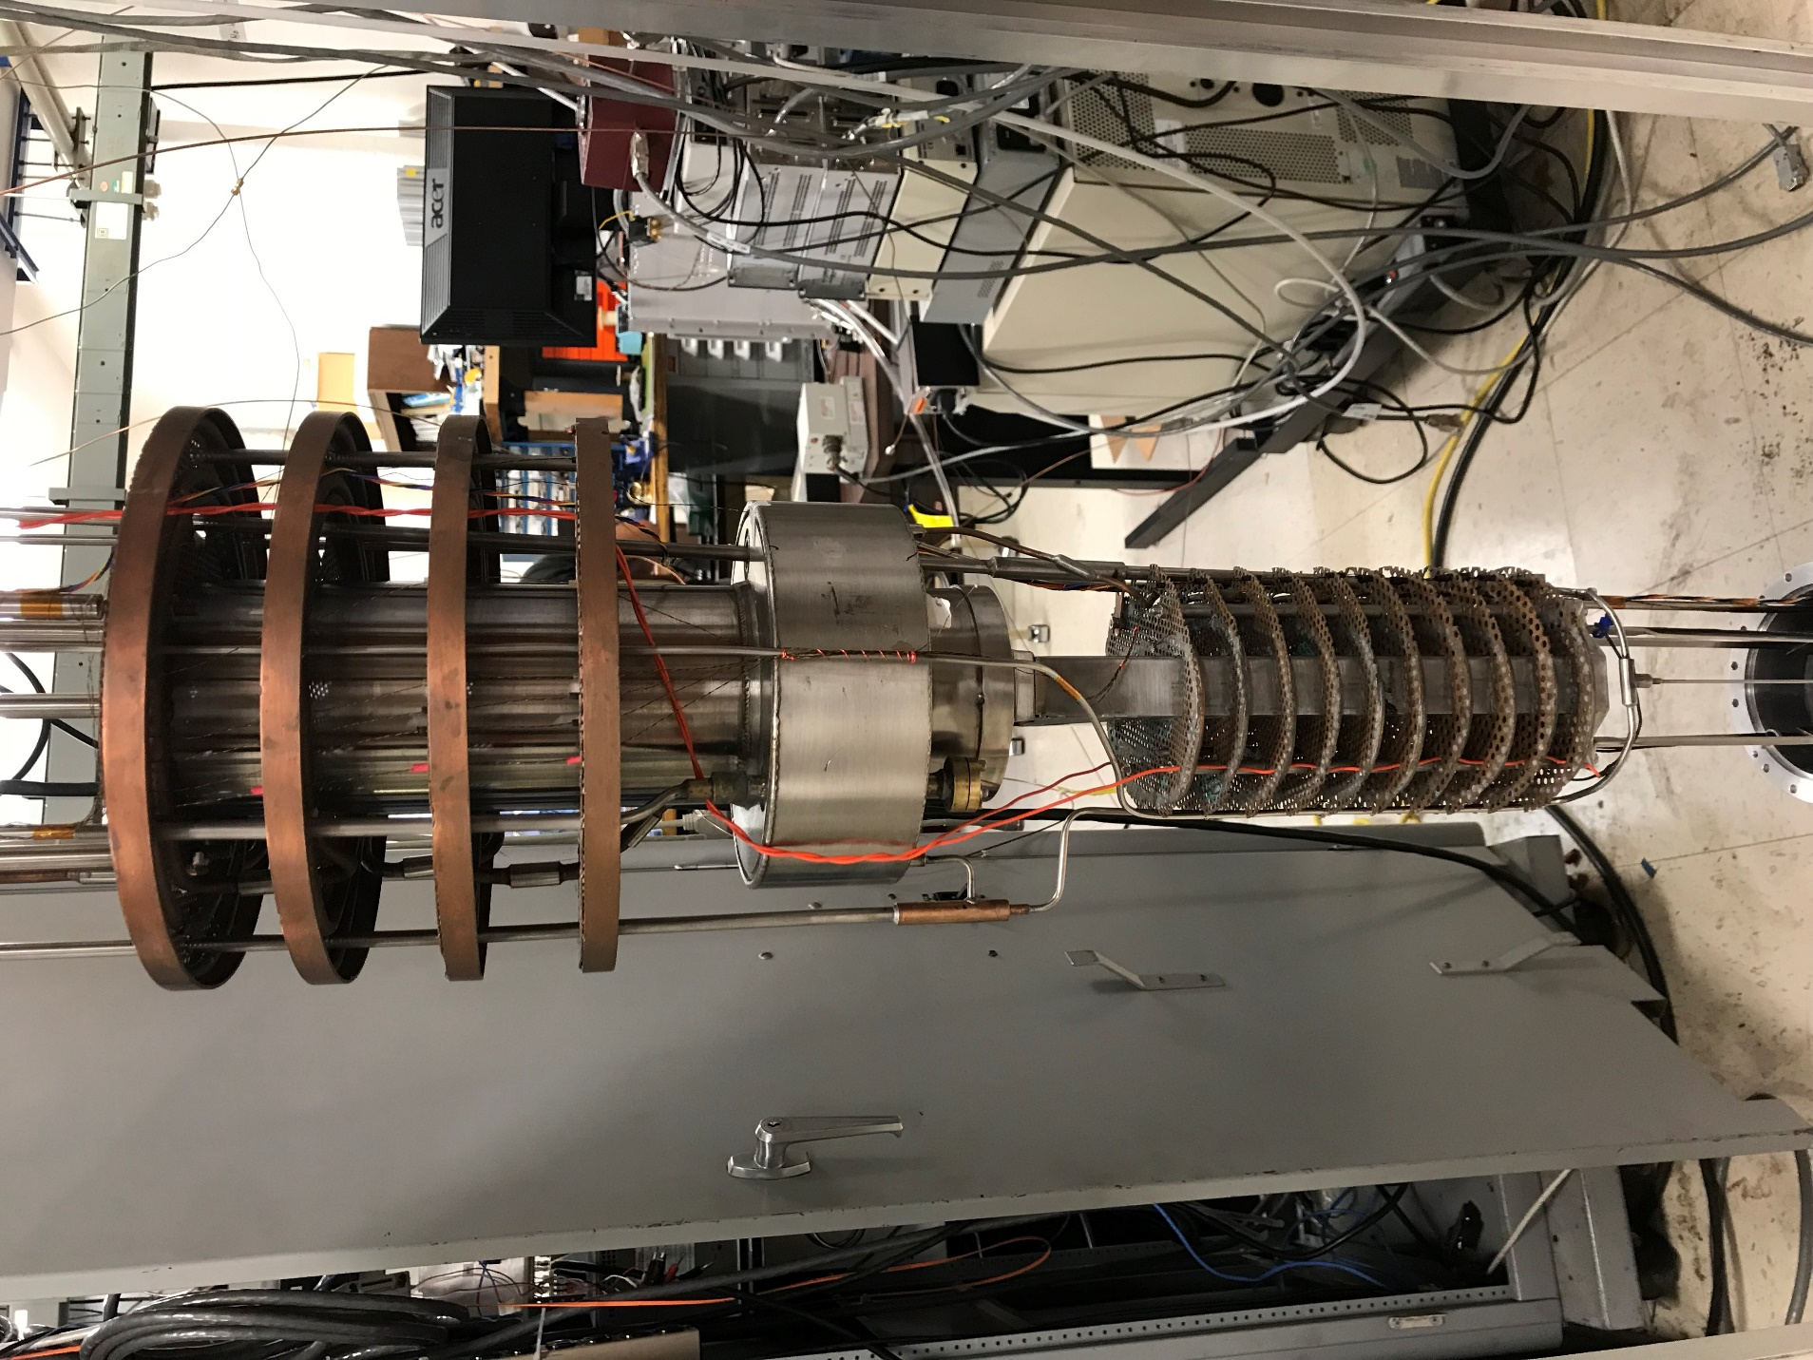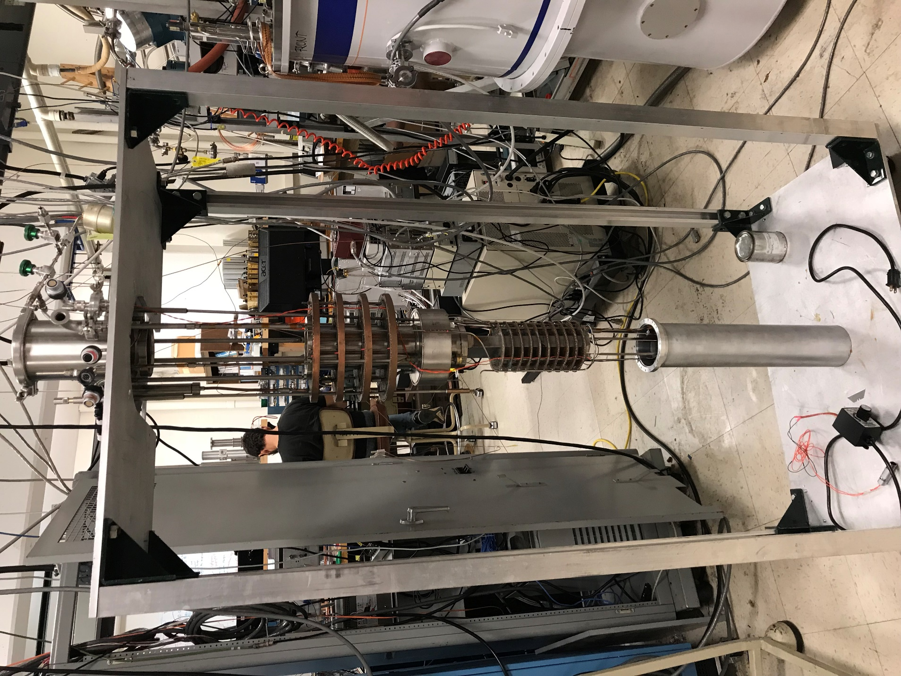
5T Magnet and Cryostat Handbook
IMPORTANT
This operating manual is intended to help the user set up and operate an Oxford Instruments Superconducting Magnet and Cryostat.
Before attempting to operate the system, PLEASE READ THE INSTRUCTIONS.
Ensure that any packing bungs (if fitted) are removed from the system before operation - instructions and information are generally stuck to the outside of the cryostat when packing bungs have been fitted - the main exception to this is when an Oxford Instruments installation has been ordered.
This product is guaranteed for 1 year against defective materials and workmanship under the general conditions of sale as detailed in the Company's order acceptance.
The guarantee does not apply to damage caused by failure of the operator to follow the recommended operating instructions. This point should particularly be remembered when dealing with the wiring.
CONTENTS
.
.
.
.
+
SECTION 1 SAFETY .......
1.1 Introduction ............
1.2 The Magnetic Field .................
1.3 Fire and Explosion Hazards ............
1.4 The Safe Handling of Cryogenic Substances ..........
1.5 Ventilation of Exhaust Gases ....................,
1.6 Environmental Safety ....
SECTION 2 DESCRIPTION AND OPERATION OF THE SYSTEM……
2.1 General Description ........
2.2 System General Arrangement...
23 Cryostat Description
2.4 Evacuating the Cryostat OVC ...
2.5 Precooling The Magnet
2.5.1 Allen-Bradley and Rhodium-Iron Sensor Characteristics
2.6 Filling the Liquid Nitrogen Container.
2.7 Transfer Tube and Storage Dewar Adapter .....
2.8 Initial Filling with Liquid Helium
2.8.1 Volumes of Liquid Helium required for Cooldown. .....
2.9 Refilling with Liquid Helium .........
2.10 Cooldown Fault Diagnosis ........
2.11 Superconducting Magnet ...............
2.12 Operating the Magnet ..................
2.13 Emergency De-Energisation Procedure ............
2.14 Magnet and Power Supply Problem Diagnosis ..........
2.15 Magnet Electrical Access ...........
2.16 Independent Shims and Current Settings. .....
2.17 Independent Shim Wiring Diagrams ......
2.18 System Closedown ....................
2.19 Typical Installation Requirements
2.20 Assembling and Dismantling the System .....
2.21 System Wiring Diagram
SECTION 3 TEST RESULTS
3.1 Magnet Test Results ....
3.2 Cryostat Test Results ...
3.3 Field Profile ........
ILLUSTRATIONS
SCHEMATIC OF LIQUID HELIUM TRANSFER. .....
EQUIVALENT CIRCUIT OF A TYPICAL MAGNET .........
OXFORD INSTRUMENTS PS120-10V POWER SUPPLY ......
EMERGENCY DE-ENERGISATION CIRCUIT DIAGRAM ...........

SECTION 1 SAFETY

  - Introduction
A superconducting Magnet System can be operated easily and safely provided the correct procedures are obeyed and certain precautions observed.
This safety section must be read and understood by everyone who comes into contact with a Superconducting Magnet System. They are NOT for the sole information of senior or specialist staff. Proper training procedures must be undertaken to familiarise effectively all persons concerned with such equipment with these requirements. Also since the field from the magnet is 3-dimensional, consideration must be given to floors above and below the magnet as well as the surrounding space on the same level.
The installation and operation of a Superconducting Magnet System presents a number of hazards of which all personnel must be aware. It is essential that:
- Areas in which magnet systems are worked on or used, and their installation generally, are planned with full consideration for safety.
- Such premises and installations are operated in a safe manner and in accordance with proper procedures.
- Adequate training is given to personnel.
- Clear notices are placed and maintained to effectively warn people that they are entering a hazardous area.
- All health and safety procedures are observed.
These notes outline aspects of operation and installation which are of particular importance, however, the recommendations given cannot cover every eventuality and it any doubt arises during the operation of the system the user is strongly advised to contact the supplier.
It is the obligation of Oxford's customers to communicate effectively to their own customers and to users of the equipment the information in this manual regarding safety procedures and hazards associated with magnet systems.
FLOOR LOADING
Professional assistance from a civil or structural engineer should be sought when considering any installation.
  - The Magnetic Field
Certain precautions must be taken to ensure that hazards will not exist due to the effect of a magnetic field on magnetic materials or on surgical implants. Typical of such effects are the following:
Large attractive forces may be exerted on equipment brought near to the magnet. The force may become farge enough to move the equipment uncontrollably towards the magnet. Small pieces of equipment may therefore become projectiles, large equipment (e.g. gas bottles, power supplies) could cause bodies or limbs to become trapped between the equipment and the magnet. Either type of object may cause injury or death. The closer to the magnet, the larger the force. The larger the equipment mass, the larger the force.
The operation of medical electronic implants, such as cardiac pacemakers, may be affected either by static or changing magnetic fields. Pacemakers do not all respond in the same way or at the same field level it exposed to fields above 5 gauss.
Other medical implants, such as aneurysm clips, surgical clips or prostheses, may contain ferromagnetic materials and therefore would be subject to strong forces near to the magnet. This could result in injury or death. Additionally, in the vicinity of rapidly changing fields (e.g. pulsed gradient fields), eddy currents may be induced in the implant resulting in heat generation.
The operation of equipment may be directly affected by the presence of large magnetic fields. Items such as watches, tape recorders and cameras may be magnetised and irreparably damaged if exposed to fields above 10 gauss. Information encoded magnetically on credit cards and magnetic tape including computer floppy discs, may be irreversibly corrupted. Electrical transformers may become magnetically saturated in fields above 50 gauss. The safety characteristics of equipment may also be affected.
To prevent situations as described above from occurring, the following general precautions are provided as guidelines. These should be regarded as minimum requirements. Every magnet site location should be reviewed individually to determine precautions to be taken against the above hazards. Also, since the field from the magnet is 3-dimensional, consideration must be given to floors above and below the magnet as well as the surrounding space on the same level.
Before ramping the magnet to field, the following precautions must be taken:
- Ensure all loose ferromagnetic objects are removed from within 2 meters of the OVC, or 3 meters for high field magnets ( >11 Tesla).
- At all points of access to the magnet room display warning signs that the magnet is operating.
- Display warning signs giving notice of the possible presence of magnet fields and of the potential hazards in all areas where the field may exceed 5 gauss.
- Ensure all electronics and interfacing equipment supplied by Oxford Instruments are placed in areas where the field level is less than 10 gauss.
- The safe working field level of other equipment must be individually
assessed by the system manufacturer.
After ramping the magnet to field:
- Do not bring ferromagnetic objects into the magnet room.
- Use only non-magnetic cylinders and dewars for storage/transfer of compressed gas or cryogenic liquids. Equipment for transportation of cylinder / dewars must be non-magnetic.
  - Fire and Explosion Hazards
In the case of fire evacuate personnel from the area, sound the fire alarm.
Water must not be used on electrical equipment and when sprayed on cryogenic liquids will rapidly freeze. The magnet ventilation may become blocked by ice with subsequent risk of explosion and the release of cryogens from the system.
The surface temperature of containers for liquid nitrogen and helium, if not vacuum insulated, may be sufficiently low to condense oxygen or oxygen enriched air. This liquid in contact with flammable substances can become explosive.
Portable fire fighting equipment must be non-magnetic and should be installed by agreement with the local fire authority.
Local emergency services must be informed of the presence of a magnet operating in their area as this may affect their procedures in dealing with fires or other accidents.
In case of a large cryogen spillage avoid direct contact with the liquid; sound fire alarm and evacuate the area.
Oil mist filters should be fitted to pumps to reduce the emission of toxic oil vapours which pose both health and explosion hazards.
  - The Safe Handling of Cryogenic Substances
Cryogenic liquids can be handled easily and sately provided certain precautions are obeyed. The recommendations in this section are by no means exhaustive and when in doubt the user is advised to consult the supplier.
The safe handling of cryogenic liquids requires a knowledge of the properties of these liquids, common sense and sufficient understanding to predict the future behaviour of such liquids under certain physical conditions.
The substances referred to in these recommendations are nitrogen, air and helium.
1 GENERAL SAFETY RULES
Cryogenic liquids, even when kept in insulated storage vessels (dewars), remain at a constant temperature at their respective boiling points and will gradually evaporate. The very large increase in volume accompanying this vaporisation is approximately 700:1 for helium and nitrogen and therefore: CONTAINERS OF CRYOGENIC LIQUIDS MUST NOT BE COMPLETELY CLOSED AS THIS WOULD RESULT IN A LARGE BUILD UP IN PRESSURE AND THUS PRESENT AN EXPLOSION HAZARD. The nitrogen jackets is always fitted with a non-removable overpressure valve, the OVC is fitted with a combined overpressure / evacuation valve and the helium bath must have the large black and red quench valve fitted. (This is normally supplied in the spares kit or left attached to the helium exit port).
In the event of a large spillage operate the fire alarm and evacuate the area.
- HEALTH HAZARDS
Asphyxia of varying severity will occur if the magnet room is not properly ventilated. (Helium can displace air from the top of a room and cold nitrogen can displace air from lower levels).
Burns. Cryogenic substances in liquid or vapour form or as low temperature gases produce effects on the skin similar to burns (cold burns).
Exposed or insufficiently protected parts of the body coming into contact with uninsulated venting pipes or vessels (see ventilation section) will stick fast and the flesh will be torn if removed.
- FIRST AID
If any of the cryogenic liquids come into contact with eyes or skin, immediately flood the affected area with large quantities of cold or tepid water and then apply cold compresses. Never use hot water or dry heat. MEDICAL ADVICE SHOULD BE SOUGHT IMMEDIATELY.
- PROTECTIVE CLOTHING
Protective clothing must be worn mainly to avoid cold burns and dry leather or PVC gloves must be worn when handling or working with cryogenic liquids. Gloves must be loose fitting so that they can be removed easily in case of liquid spillage. Eyes must be protected by goggles. Do not wear any metallic objects (e.g. jewellery) on those parts of the body where they may come into contact with the liquid.
- HANDLING
Cryogenic liquids must be handled and stored in well ventilated areas.
Do not allow cryogens to come into contact with the body.
Always handle the liquids carefully - boiling and splashing will always occur when filling a warm container or when inserting warm objects into the liquid. When inserting open ended pipes into the liquid, block off the warm end until the cold end has cooled down (otherwise cold liquid may spurt out of the open end under self-generated pressure). Never direct pipe/piping towards any person.
Beware of liquid splashing and rapid flash-off of helium when lowering equipment at ambient temperature into liquid. This operation must be carried out very slowly.
Use only metal tubing connected by flexible metal hose for transferring liquid nitrogen. For the coupling DO NOT use rubber tube, silicon rubber tube (including hospital grade tube - this explodes!) or plastic tubing e.g garden hose and including reinforced tubes e.g. for air lines - this shatters unexpectedly and may cause injury to personnel. It should be noted that polythene and nylon lines are sometimes used however this should not be taken as an implied recommendation, all lines should be tested in safe circumstances or used only after the manufacturer's recommendation.
- EQUIPMENT
Only use containers specifically designed for use with particular cryogens and constructed of non-magnetic materials.
- LIQUID NITROGEN
Good ventilation is essential.
Store and use in a well ventilated place. If enough gas evaporates from the liquid in an unventilated place (e.g. overnight in a closed room) the oxygen concentration in the air may become dangerously low. Unconsciousness may result suddenly without previous warning symptoms and may be fatal. For example, the evaporation of 25 litres of liquid nitrogen produces 17,000 litres of nitrogen gas (600 cu.ft.). If this vaporization takes place in a room of 54 m3 (2,000 cu.ft.), i.e. 3 x 6 x 3 metres high (10 x 20 x 10 feet high) it can produce a very dangerous situation if the room is not ventilated. Appropriate multiplication of these parameters will indicate actual site conditions.
Minimize contact with air
Since liquid nitrogen is colder than liquid oxygen, the oxygen of the air will condense into the nitrogen and if allowed to continue for some time, the oxygen concentration may become so high that the liquid may become as dangerous to handle as liquid oxygen. This applies particularly to wide-necked dewars. Therefore ensure that contact with air is kept to a minimum.
Do not smoke
Rooms in which cryogenic liquids are being handled should be designated no smoking areas. While nitrogen and helium do not support combustion, their extreme cold can cause oxygen from the air to condense on cold surfaces and may increase the oxygen concentration locally. There is a particular fire danger if the cold surfaces are covered with oil or grease which is itself combustible.
- LIQUD HELIUM
Liquid helium is the coldest of all cryogenic liquids. It will therefore condense and solidify any other gas (air) coming into contact with it, with the consequent danger that pipes and vents may become blocked.
Liquid helium must be kept in specially designed, storage or transport dewars.
Dewars should have a non-return valve fitted in the helium neck at all times in order to avoid air entering the neck and plugging it with ice. Vacuum insulated pipes should be used for liquid transfer; breakdown of the insulation may give rise to condensation of oxygen.
1.5 Ventilation of Exhaust Gases
Gaseous nitrogen and helium exhausted from the cryostat will displace oxygen and if not properly ventilated, the possibility of asphyxiation exists.
Cryogenic substances in liquid, or vapour form, or as low temperature gases, produce effects on the skin similar to burns (cold burns).
Exposed or insufficiently protected parts of the body coming into contact with uninsulated venting pipes or vessels will stick fast and the flesh may be torn if removed.
Exhaust systems are required in order to vent to atmosphere any discharge from the system cryostat as described below.
The static helium evaporation exits from the turret via a non-return valve. The valve prevents ambient air leaking back into the cryostat. The outlet from this valve should be vented out of the room to atmosphere or, it required, to a helium recovery system. In the event of a quench the evaporated helium will be exhausted from the manifold via the pressure relief valve(s). The amount of gas is dependent on the type of system, but for a 500MHZ NMR magnet quenching with 100% helium the volume of gas at room temperature will be approximately 50,000 litres. If the system is located in a small room then a system should be provided that is capable of exhausting this gas to atmosphere or to a recovery system.
The static nitrogen evaporation will exit from one (or two) of the nitrogen ports. This gas should be vented out of the room to atmosphere.
1.6 Environmental Safety
It is the responsibility of the user to ensure that all equipment, services, data links or personnel passing through the affected space are adequately protected and that access to the area is controlled. Access doors leading into the affected areas must be capable of being secured against unauthorised entry and fitted with warning signs, it is also recommended that local barriers be erected around the magnet and be fitted with warning signs. Care must be taken to advise personnel who have access (in particular security or cleaning staff who often have their own keys) of all the risks associated with magnetic fields and systems operating with cryogens.
SECTION 2 DESCRIPTION AND OPERATION OF THE SYSTEM
2.1 General Description
This system comprises a special horizontal field 5T split pair magnet mounted in the tail section of a large capacity, liquid nitrogen shielded, vacuum insulated cryostat. The magnet has a cold split of 100mm x 40mm and a cold bore diameter of approximately 120mm, accessed through aluminium windows. Alternatively room temperature bore tubes may be inserted to allow the magnetic field to be plotted. The vertical split access allows a large cooling power helium-4 insert to be fitted from above. This insert will be described in a separate manual,
The cryogenic efficiency of the cryostat is very high due to the small helium neck diameters and the way in which the exhausting helium gas is used to cool them. The helium can heat load is minimised by the use of a nitrogen cooled shield which will minimise both the conducted and radiated heat to the minimum levels possible.
The current leads are all fixed for high reliability and safe operation.
The magnet is 5T with a homogeneity of better than 1 in 10⁻⁴ over a length of 20mm and a diameter of 80mm. See the results at the end of the manual for more detailed information. Access is provided through aluminium windows which may be demounted it required for access to the magnet cold bore.
The weight of the system is approx 1000Kg. Appropriate lifting gear must be used to move the cryostat.
This system, when energised to full field has a considerable stray field, extending over many metres, and the system stored energy is approx 0.5MJ. It is therefore VITAL that the safety section is read by ALL personnel coming near the system.
PARTICULAR CARE MUST BE TAKEN TO ENSURE THAT THE SYSTEM IS WELL ANCHORED TO THE FLOOR, AND ANY STEEL OBJECTS IN THE VICINITY ARE SIMILARLY WELL BOLTED TO THE FLOOR.
A detailed description of the system components follows.
2.2 System General Arrangement
Please see Blueprint supplied separately.
Drawing no. ALD0039 4/92.
2.3 Cryostat Description
The cryostat is of a vacuum insulated, all metal construction with intermediate temperature radiation shielding. The outside surfaces of the helium and nitrogen vessels are wrapped with single or multilayer superinsulation to reduce emissivity. The outer vacuum case (OVC) of the dewar will be fitted with an evacuation valve incorporating a pressure relief safety feature that will operate in the event of a cryogen leak to the vacuum space. In addition there is a drop-off plate at the base or side of the dewar.
The syphon entry port has an associated cone located within the cryostat. A tube runs from the cone to the bottom of the cryostat and ensures that all liquid nitrogen can be removed from the helium reservoir after pre-cooling the magnet and that filling with helium is from the bottom. All cryomagnet service ports should be sealed with the plugs provided when not in use. In all cases the boil-off of cryogens is minimised by taking great care in the design to prevent heat entering from the following main sources:
1). Gaseous conduction. An evacuation / pressure relief valve allows the insulating vacuum space to be evacuated to less than 10⁻⁴ torr.
2). Metallic conduction. Great care is always taken to use materials of low thermal conductivity combined with mechanical strength to support the cryogens in their vacuum. The supports (usually tubes) are of minimum cross sectional area and maximum effective length within overall size constraints. Neck tubes are thermally anchored with a copper thermal link to the top of the nitrogen vessel and good use is made of the enthalpy of the exhausting gas to minimise incoming conducted heat.
3). Radiation. The radiation load is reduced to reasonable values by the introduction of intermediate temperature radiation shields. These are usually cooled by a reservoir of liquid nitrogen surrounding the helium bath. The enthalpy of the exhausting helium gas is sometimes used to cool a radiation shield inside the nitrogen shield. The emissivity of cold surfaces can also be reduced. This is achieved using many interleaved layers of aluminium and insulation known as superinsulation.
4). Ohmic heating. The principal sources of ohmic heating are the current leads and the superconducting switch. In some systems the current leads are made demountable to minimise the cryogen boil-off with a persistent magnet, the remainder of systems feature carefully designed current leads which do not impose a significant heat load. All systems now feature low-loss switches.
2.4 Evacuating the Cryostat OVC
In order to maintain the thermal isolation of the liquid helium it is necessary that a high vacuum be maintained within the cryostat outer vacuum case (O.V.C.).
IMPORTANT: In many cases the thin wall construction of the helium reservoir will not support an external pressure differential of one atmosphere. The helium reservoir must therefore never be evacuated unless the OVC is first evacuated. The recommended pumping equipment consists of an oil diffusion pump of 50mm (2 inch) diameter or, even better, a turbomolecular pump fitted with a liquid nitrogen cold trap. This pump should be backed by a rotary pump of not less than 12-15 m³/hr pumping speed, fitted with a gas ballast facility. All connecting lines should have an internal diameter of not less than 50mm (2 inch) and be as short as possible. Tubes must NOT have been used previously to carry or pump helium.
  - Connect the valve on the cryostat top flange to the pumping equipment. Using the rotary pump, evacuate the cryostat slowly (approx half hour) to prevent any possible collapse of internal shielding, until the pressure is less than 0.05 mB.
  - Switch over to the diffusion pump and evacuate the cryostat to less than 5 x 10⁻⁴ mB. Continue pumping at least overnight to ensure the removal of residual gases trapped in the superinsulation.
Inspecting the vacuum:
If the cryostat is already evacuated and it is desired to inspect the pressure only, the pumping tube should be evacuated and the diffusion pump operating before the O.V.C. valve is opened. If the pressure is greater than 10⁻³ mb with the system warm, the cryostat should be evacuated overnight with the diffusion pump to less than 5 x 10⁻⁴ mb. It is recommended that the cryostat is always pumped overnight before use.
Flushing the vacuum space:
If the vacuum space has been accidentally contaminated with helium gas or moisture evacuation can be improved by flushing the space. NOTE: Never vent cryostats with helium gas as this will ‘stick’ in the superinsulation.
- Using a rotary pump, evacuate cryostat to less than 1 mB.
- Admit an atmosphere of DRY nitrogen gas, preferably through a 1mm orifice, and pump out to less than 1 mB.
- Repeat (ii) several times, then pump to less than 0.05 mB.
- Switch over to the diffusion pump as in (b) above.

*Charles Mitchell advises with our system to just put in LN₂ until magnet is cold and then flow it out – don’t let it sit as these instructions say. SJB 1-May-92.
2.5 Precooling The Magnet
Before filling the cryostat with liquid helium, the magnet and system must be cooled to a temperature below 100K, this will save a considerable amount of liquid helium which is much (ten times) more expensive than liquid nitrogen, liquid nitrogen also has a higher latent heat of vaporisation. To perform the precool, fill the liquid helium container with liquid nitrogen, completely above the magnet. Use a length of 9.6 mm (3/8 in.) diameter stainless steel tubing inserted into the transfer tube entry port (this is the 'blow-out' tube supplied with the system). Ensure that the tube is located in the cone fitting below the syphon entry port inside the cryostat, the liquid nitrogen storage dewar should be conveniently positioned and connected to the blow-out tube with flexible plastic tubing (once the transfer has started this should not be moved as it is very brittle and will break easily). Allow the liquid nitrogen to remain for one or two hours and then fill it completely again.
The liquid nitrogen should then be removed. Insert the stainless steel tube into the transfer entry fitting and ensure that it is firmly fitted into the cone on the top of the magnet. Blow out all the liquid nitrogen by pressurising the liquid helium container with helium gas to not more than 0.25 atmospheres overpressure, the blown out liquid nitrogen may then be usefully fed into the nitrogen can, see section 2.6 on page 16. Do not stop this prematurely as removing the remaining nitrogen could cause problems. Use the heaters on the helium can to remove the last few litres of liquid nitrogen that will be left in the helium can. Monitor the background in the OVC with a leak detector connected to the OVC pumping line to check for low temperature leaks from the main bath to the OVC. It is important that all the liquid nitrogen is removed. Failure to do this properly will make filling with the liquid helium difficult, and may impair the performance of the magnet. When all the nitrogen has been removed, release the pressure in the liquid helium bath and evacuate the liquid helium container using a rotary pump and then fill it with helium gas. If during pump down a pause is seen in the range 70-100 ml, and the pumping line becomes very cold, then liquid nitrogen is still present. Stop pumping immediately and flush out the helium bath with helium gas ted down the blow out tube (which should be located in the cone fitting). Failure to do this will result in solidification of the nitrogen. Repeat this procedure at least two times in order to thoroughly purge the magnet of nitrogen. As an indication that all the liquid nitrogen has been removed, check that it is possible to evacuate the liquid helium container to a pressure less than 10 mB.
2.5.1 Allen-Bradley and Rhodium-Iron Sensor Characteristics
Please note that this sheet is a guide for cooldown monitoring purposes only, and is not a substitute for a full calibration.
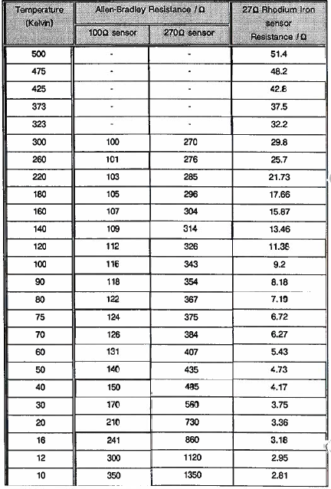
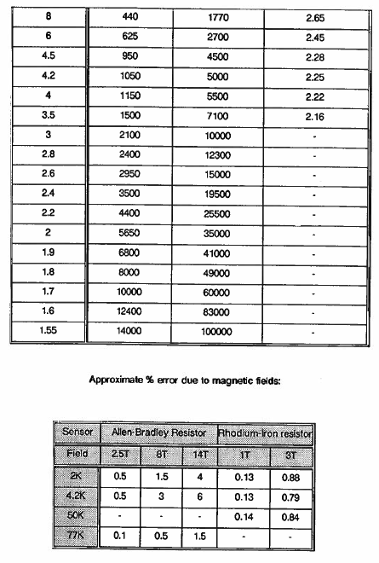
2.6 Filling the Liquid Nitrogen Container.
In the interests of economy it is advisable to precool the magnet before filling the nitrogen can. The procedure for this is described previously and will ensure that the cryogens are most efficiently used.
Connect one of the three filler/vent tubes of the liquid nitrogen container to a storage vessel using flexible polythene pipe. Transfer the liquid nitrogen by pressurising the storage vessel to approximately 0.25 atmospheres above atmospheric pressure. Violent boiling will occur initially until the radiation shield has cooled down. When liquid nitrogen sprays out of the filler tubes release the pressure on the storage vessel to stop the transfer.
The storage vessel can be pressurised using a valve on the outlet. By using an electronically controlled valve, the liquid nitrogen container can be filled and the level maintained using a Liquid Nitrogen Level Controller. Inspect the liquid nitrogen at intervals appropriate to the overall system hold time.
All Oxford Instruments cryostats are fitted with overpressure relief valves which are not customer removable. The problems caused by ice formation in the filling tubes can be reduced by slipping 0.25m (10 in.) lengths of plastic tubing over them. These tubes also prevent any overflow of liquid nitrogen from cooling the top flange and its 'O' ring. This can be important if an autofilling system fails to stop the nitrogen transfer when the tank is full.
2.7 Transfer Tube and Storage Dewar Adapter for Liquid Helium
The transfer tube optionally provided with the system is of a stainless steel construction. It takes the form of a tube surrounded by a second tube with a vacuum of better than 10⁻⁴ mB maintained between them. The assembly of the two tubes usually takes the form of a large 'n' shape.
For detailed instructions on initial filling and topping-up the reader is referred to sections 2.8 and 2.9 (on pages 19 and 20) respectively.
Occasional repumping of the tube will be necessary in service, particularly during the first few months while the materials in the tube are still outgassing.
2.7.1 The ST9 Syphon Evacuation Fitting
The transfer syphons supplied by Oxford Instruments are supplied pre-evacuated, however re-evacuation may become necessary after a period of operation. To evacuate an Oxford Instruments standard syphon, an ST9 fitting is needed to operate the vacuum valve.
- Remove the yellow nylon dust cap from the transfer tube valve. Connect the ST9 fitting to the high vacuum pumping system described in Section 2.4 (page 11).
- Place the ST9 fitting over the transter tube valve. Evacuate the pumping lines and check the system for leaks.
- Using the red anodized aluminium knob, which is connected to the hexagonal key internally, open the transfer tube valve. Pump out the syphon to 10⁻⁴ mB or better.
- Close the transfer tube valve using the red knob, isolate the pump and remove the ST9.
- Replace the dust cap.
- Try to avoid getting dirt in the ST9 fitting.
Note: The cryostat over pressure relief valve must be in position and not restricted. If the cryostat is connected to a recovery system any flow meter should be capable of high flow rates and should not introduce a restriction (it may be sensible to fit a bypass flap valve to accommodate the high flows during a possible quench, ensuring that all the helium is recovered).
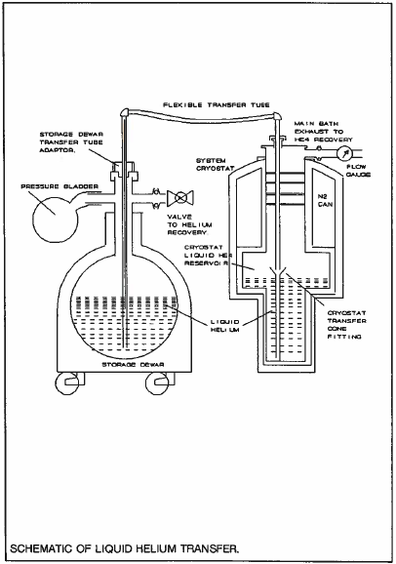

2.8 Initial Filling with Liquid Helium
Note: See also the instructions for the storage dewar.
- Check that the transfer tube has the correct leg lengths and diameters to be compatible with the cryostat and storage dewar. Connect the cryostat and storage dewar to the helium recovery system or put a oneway valve on the cryostat exhaust port (if the system is large and a one way valve is found too restrictive, it may be replaced by a 2m length of convoluted tubing). Position the liquid helium storage vessel so that the transfer tube can be inserted easily and is close to the cryostat to be filled.
- Remove the plug from the cryostat transfer tube entry port and also from the top of the storage vessel. Insert the transfer tube legs into the cryostat and, slowly, into the storage dewar, allowing it to cool gradually. Ensure that the end of the transfer tube in the cryostat is fitted into the cone on top of the magnet. In this way, cold gas and then liquid is introduced at the bottom of the magnet which is then cooled by the enthalpy of the gas as well as by the latent heat of evaporation.
- Start transferring the liquid helium by pressurising the storage vessel. (This is generally done by gently squeezing a rubber bladder). The transfer rate should be such that the vent pipe is frozen for not more than 2 m (6 ft.) of its length. The initial transfer rate should be equivalent to about 10 litres of liquid per hour. This rate can be increased as the magnet cools and the boil-off reduces. Typically the cool-down from 77K to 4,2K will take between 10 and 60 litres depending on the system size and the care taken in the transfer.
By monitoring the Allen-Bradley sensors, when the magnet temperature falls below 10 Kelvin, the transfer rate can be further increased in order to fill the liquid helium container. This should occur when a further 10 to 50 litres of liquid have been transferred, depending on the size of magnet and dewar.
4.) When the liquid helium reservoir has been filled, stop the transfer by releasing the pressure in the storage vessel. Remove the transfer tube and replace the plug. Inspect the liquid helium level at appropriate intervals.
2.8.1 Volumes of Liquid Helium required for Cooldown.
The typical volumes of cryogens required for cooldown are given in the results section.
2.9 Refilling with Liquid Helium
The cryostat should be refilled before the level reaches the 10% mark (it a helium level meter is in use). In refilling, care should be taken not to evaporate the liquid in the cryostat with the hot gas which initially comes through the transfer tube. (N.B. Failure to take care can cause the magnet to quench).
With Oxford Instruments syphons a 'phase separator' is supplied. This is a small brass cylinder approximately 25mm long x 10mm diameter with an internal screw thread at one end and two angled cuts in the curved surface, it does not have a hole right through. The phase separator may be screwed to the end of the syphon leg which enters the cryostat, the liquid / gas passing through the transfer line is then separated as it is thrown upwards by the angled slots and the liquid simply falls back under gravity to collect in the base of the helium can. The phase separator is particularly useful when the refilling is intermittent (eg with autofilling systems, or transfer lines left permanently in the cryostat) as liquid in the transfer line may have vaporised and this is then not passed through the colder liquid in the cryostat, which would cause it to boil off. The phase separator should not be used for initial cooling of the system.
The correct procedure is as follows:
- Insert one leg of the transfer tube into the storage vessel, but leave the other one outside of the cryostat. The cryostat syphon entry fittings (the O-ring, washer and the knurled ring) should be undone and slid onto the transfer leg to go into the cryostat, reseal the cryostat entry with the bung provided, the syphon may now be precooled without warm gas entering the cryostat. Pressurise the transport dewar in the normal way, as if transferring helium. After about a minute liquid will issue from the transfer tube, indicated by a blue tongue of vapour. (Prior to this a white vapour plume will have been seen for about 20 seconds).
- Quickly release the pressure in the transport dewar and insert the open end of the transfer tube into the cryostat.
- Lower the transfer tube until it reaches the bottom of the necktube. DO NOT push the tube into the cone on top of the magnet, or on the magnet support structure. Transfer liquid helium in the usual way.
If the helium level has fallen below 5% and the magnet is still energised there are two courses of action open:
- If the level is below 0% or if the user is not certain that a careful transfer can be done DE-ENERGISE THE MAGNET, refill and then re-energise the magnet.
- Refill the dewar, but be careful as the syphon is introduced and as the transfer starts.
The cryogen boil-off test results are given in the results section.
2.10 Cooldown Fault Diagnosis
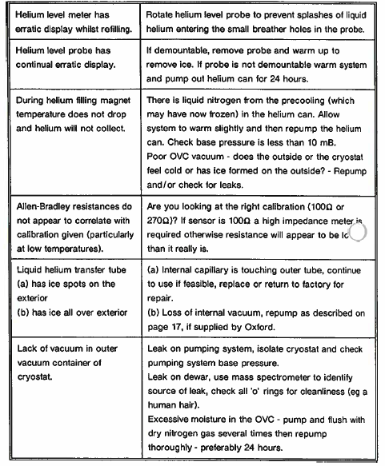
2.11 Superconducting Magnet
The magnet consists of a number of concentric solenoid sections together with compensating coils including shimming coils (when required to achieve the specified level of homogeneity). Each section is wound from multifilamentary superconducting wire formed from Niobium Titanium (NDTI) filaments surrounded by a stabilizing matrix of copper. High field magnets i.e. those with maximum fields of greater than 11 Tesla will be fitted with inner coil sections of Niobium Tin (Nb Sn). All sections are constructed to the MAGNABOND system, an integration of proprietary techniques, developed by Oxford Instruments, to give a structure which is both physically and cryogenically stable under the considerable Lorentz forces generated during operation. All the constituent sections of the magnet are connected to allow series energisation except when independently excited shims are fitted.
2.11.1 The Superconducting Switch
A superconducting switch is used to establish 'persistent mode operation, this is the temporary connection of a superconducting short circuit across the magnet leads when the magnet has the desired current flowing within. In this way the magnet may be set (persistently) at a given field, and the current in the supply leads reduced to zero. This will save a considerable amount of liquid helium due to the ohmic heating in the current leads.
The switch consists of a length of superconducting wire non-inductively wound with an electrical heater. The superconducting switch, as supplied, has this length of superconductor wired in parallel with the entire magnet. The superconducting wire is made resistive by raising its temperature using the heater. The switch is then in its open state and current, due to a voltage across the magnet terminals, will flow in the superconducting magnet windings in preference to the resistive switch element. The switch is in its closed state when the heater is turned off and the switch element becomes superconductive again. The process of establishing persistent mode operation of the magnet consists of energising the magnet to give the required field with the switch in the open state, closing the switch and then reducing the current flowing through the magnet current leads to zero, leaving the magnet in its previously energised state. The current flowing in the magnet windings remains constant as the magnet lead current is reduced, the current flowing in the closed switch then being the difference between the magnet and lead currents.
Magnets are specifically constructed for fast sweep applications may not be fitted with a switch, the advantages of this are a reduction of the boil-off whilst sweeping as switch heater current is not required, and, secondly, all the power supply current is forced through the magnet and is not shunted by the switch.
This shunt current would otherwise lead to non-linearity between the power supply current and the field, which may be undesirable for some applications.
2.11.2 Magnet Quench Protection
Protection resistors, and diodes it appropriate, are provided for all magnet sections, restricting the development of potentially high voltages in the event of a magnet quench (rapid conversion from the superconducting to the normal resistive state). The resistors also dissipate some of the energy stored in the magnet during a quench thereby reducing the energy dissipation within the magnet windings. The resistors are mounted on baffles attached to the magnet support structure or on plates above the magnet itself and hard wired or coupled to the magnet via an electrical connector. The connector will also incorporate the wiring for the superconducting switch heater, making it impossible to run the magnet without the protection circuit attached.
If barrier diodes are used in the protection circuit then, under limited voltage conditions, e.g. energisation or de-energisation of field and when the field is static, all the current passes through the magnet and ensures proportionality between energisation current and magnetic field. As no current is flowing through the protection circuit the heat load from the protection resistors and hence system boil off are reduced.
Under quench conditions, the barrier voltage is exceeded and the protection circuit shunts a proportion of the current away from the magnet windings.
2.11.3 Equivalent Circuit of a Superconducting Magnet.
A Superconducting magnet can be considered to be a pure inductor, however connections from the power supply to the magnet will of course be resistive and a small voltage will be dropped along the length of the leads (typically <0.7 volts for 5 metre leads at 120A) and along the leads inside the cryostat (typically 0.15 volts at 120A). This voltage will be roughly proportional to the current in the leads. It is a good idea to check these voltages and the cryostat boil-off, with the switch heater off (ie magnet not energised) and full current in the leads, after commissioning and any subsequent disassembly.
The switch will shunt a small amount of the magnet current whilst there is a voltage across the magnet i.e. when the field is changing. This current is minimised by running the magnet up slowly and using a high resistance (1000 ohms) switch, a worst case may be energisation at 10 Volts (the maximum output voltage from a PS120-10) through 1000 ohms i.e. 0.1A. For experiments requiring an extremely linear field versus current ratio, such as VSM measurements, a switch may not be fitted.
The protection circuitry is generally fitted with special diodes and will not pass current until a certain voltage is exceeded. This is generally 4 Volts, however some special magnets and those designed for fast ramping may have a "protection voltage" of 10 Volts (or more if a special power supply is used, such as the PS120-20). Some small magnets and magnets designed for very infrequent running up and down may have no diodes. In this case the protection circuit will dissipate power whenever a voltage is present across the magnet terminals.
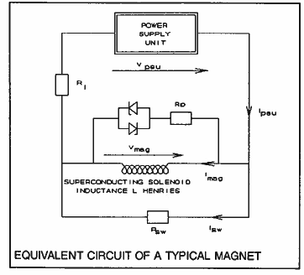

To run the magnet up to field a voltage must be applied to the magnet leads to overcome the inductance of the coil. The magnitude of this voltage will govern the speed at which the magnet will run-up, this is defined by the equation:
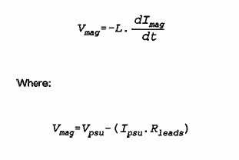
L is the magnet inductance given in the specification section.
For magnetic circuits with no iron (i.e. they are linear) the magnetic field at any point is proportional to the magnet current i.e.:
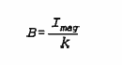
k is the current to magnetic field ratio given in the specifications section.

2.12 Operating the Magnet
Check that the quench valve is in position on the outlet from the main bath, this is VITAL as a magnet quench liberates hundreds or thousands of litres of helium and any restriction on the recovery line or exhaust port could cause an explosion. After cooling down the system and collecting liquid helium in the helium can the magnet is ready for energisation.
A magnet power supply is needed to energise the magnet. Typically an Oxford Instruments PS120-10, PS120-3 or PS120-10HS power supply would be used, however any power supply with the necessary current rating to achieve the full field of the magnet, and a voltage suitable to allow field sweeping at the desired rates may be used. The following instructions are general. Read the relevant Power Supply Unit (PSU) handbook for specific information. The magnet field strength is determined by the current available (the Tesla/ Amp ratio is given in the specifications), while the voltage determines the rate of change of field (the inductance is also given in the specifications).
The magnet can be operated manually or under control of a computer. Three modes of magnet energisation exist namely:
Current control mode with voltage trip. This allows the solenoid to be swept to a set current or zero current at a constant rate of change of current, which with resistor-diode protection allows a constant rate of energisation. If the maximum output voltage of the power supply is not capable of energising the magnet at the set rate due to the sum of the inductive back EMF and the lead drop, the power supply will trip and go into the 'Hold' state le energisation halts and can be restarted by the user at a lower sweep rate. All recent power supplies manufactured by Oxford Instruments work in this mode.
Current control mode with voltage limit. This is a similar mode to voltage trip constant current sweep rate but in the event of the voltage limit being reached, if the rate of energisation demands more voltage at the power supply than it is allowable, then the power supply will limit at that voltage but will continue to sweep to the set current.
Constant voltage. This allows the solenoid to be swept to a set current or zero at a rate dictated by a constant voltage at the power supply terminals, the voltage drop in the current leads and the inductance of the solenoid. This will not give a constant rate of energisation with increment of time and is therefore not of any interest for VSM experiments. It is mentioned here for historical reasons only and is now rarely used.
IMPORTANT: Before initial use, and if the system has not been used for sometime the following measurements should be made, and compared with the quoted values.
- Magnet continuity.
- Magnet / cryostat, switch heater / cryostat, and magnet / switch heater isolation.
- Switch heater resistance.
Suggested sweep rates are described in the specification section of this manual.

2.12.1 Running the magnet with a PS120-10, PS120-3 or PS120-10 HS Power supply.
The following instructions assume that an OXFORD INSTRUMENTS PSxxx-yytype magnet power supply is being used. (xxx defines the maximum current, yy defines the maximum output voltage). The instructions that follow are sufficient to cover the basics of running a magnet. For more detailed instructions and description, consult the power supply instruction manual.
The PSxxx-yy allows operation of the magnet either manually or under control of a computer (using the RS232 link, of IEEE488 interface it the optional converter is fitted).
IMPORTANT: Before initial use, and if the system has not been used for some time the following measurements should be made, and compared with the quoted values.
1) Magnet resistance
2) Magnet to cryostat isolation
3) Switch heater resistance
4) Switch heater to cryostat isolation
5) Magnet to switch heater isolation

1.) Before connecting the PSxxx-yyto the electricity supply, check the rating plate on the rear of the unit corresponds with the supply voltage being used. Now connect the magnet current leads and the persistent mode switch heater lead to the terminals inside the rear cover of the power supply.
2.) Connect the leads to the cryostat magnet terminals and the appropriate ten pin seal. Check for electrical isolation from the cryostat.
3.) Switch on the magnet power supply. The power supply will indicate successful initialisation by displaying the firmware version eg 'PS2.04, then 0.00.
4.) Select the mode of display required, this can be in Amps or Tesla by pressing the button labelled CURRENT/FIELD (the ratio of these is set in the software for a given magnet).
Set the current or magnetic field to which the magnet is to be energised by pressing the RAISE and LOWER buttons on the ADJUST panel while depressing the SET POINT button on the DISPLAY panel. Set the rate of change in a similar way by pressing RAISE and LOWER while depressing the SET RATE button. Please consult the results section of this manual for advised energisation limits.
5.) If the magnet is equipped with a persistent mode switch, press the HEATER ON button on the SWITCH HEATER panel. The button should be pressed, the indicator light will come on, Wait 30 seconds to allow the switch to heat up before proceeding.
6.) The magnet energisation can now be started by pressing the SET POINT button on the SWEEP CONTROL panel. The current or field will be seen to increase on the digital display and the output voltage will have been seen to kick over to the voltage needed to overcome the magnet impedance on the analogue meter (if fitted, ie not the PS120-3).
7.) When the set point has been reached, the switch heater can be turned off by pressing the HEATER ON button again. After waiting about 30 seconds for the switch to become superconducting, press the ZERO button on the SWEEP CONTROL panel. The current in the magnet leads will decrease to zero leaving the magnet, still energised, in persistent mode. The rate at which the leads alone can be swept is faster than the magnet and leads, this is automatically taken into account in the power supply firmware.
8.) The magnet can be taken out of persistent mode by using the following procedure:
Pressing the SET POINT button on the SWEEP CONTROL panel (the switch heater is left 'off’). The current leads will be swept at a fast rate to the Set Point value. Turn the switch heater current 'on' by pressing the HEATER ON button. Wait 30 seconds for the switch to warm up. Press the ZERO button on the SWEEP CONTROL panel and the magnet will start to de-energise. The Set Rate can be increased during the sweep without stopping.

If it is desired to change the value of magnetic field, sweep the current leads to the present current or field of the magnet, press HOLD, open the switch by turning on the heater. Press the SET POINT button and RAISE and LOWER to change the Set Point to the new desired value. Make changes to the Set Rate of sweep in a similar manner. Press the SET POINT button on the SWEEP CONTROL panel and the magnet will either energise or de-energise to the new field.
If the voltage needed to drive the magnet at a given rate is such that the maximum voltage of the power supply will be exceeded, the power supply will trip into the 'Hold' mode, and the HOLD light will illuminate, on the SWEEP CONTROL panel. The sweep can continue, after a slower rate has been selected, and the SET POINT button has been depressed.
In the event of a magnet quench, the power supply will trip to zero amps and the QUENCH light will illuminate.
A diagram of the front panel layout is shown in the diagram on page 31.
Useful facilities on the PSxxx-yy power supplies include automatic running down of the magnet (whatever state it is in) if the helium level falls below a threshold value. Please see the power supply manual (See Autorundown section).
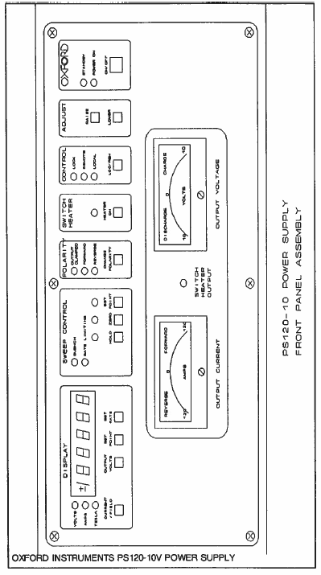
2.12.2 Current control mode with voltage limit or trip
NOTE: This mode is not used with Oxford Instruments power supplies and is included for information only.
- Connect the magnet leads and persistent mode switch heater leads. Check for electrical isolation from the cryostat.
- Switch on the magnet power supply, then set the power supply to constant current mode, with voltage limiting or trip.
- Set the output voltage limits to the required level on the power supply.
- Set the current for the required field on the power supply and the current sweep rate. (N.B. this may change several times during a sweep, the actual sweep rates are defined in the specifications section).
- Turn the switch heater ON wait 30 seconds. Start the sweep to field by allowing the current output of the power supply to start sweeping on the power supply.
- When the magnet has reached field and the voltage at the power supply has died away to the voltage drop in the current leads, turn the switch heater OFF. Wait 30 seconds, then sweep the current from the power supply back down. The sweep rate is not critical. This will cause the leads to run down leaving the magnet in persistent mode.
If the ramp rate is too high the voltage across the magnet will exceed the set positive voltage. This will either cause the power supply to continue energisation but at a rate dictated by the set voltage, or trip and allow the magnet current to decay at a rate dictated by the negative set voltage. The mode in which the power supply is set will dictate which of these two cases will apply.
To take the magnet out of persistent mode:
- With the switch heater OFF, run the leads to the set current.
- Turn the switch heater ON and wait 30 seconds.
- Re-set the current sweep rate required for de-energisation and allow the power supply current to sweep down. The magnet will sweep to zero amps at the prescribed rate providing it is less than that allowed by the negative voltage setting.
IMPORTANT: If the magnet has been left in persistent mode and the power supply disconnected, briefly short circuit the output current terminals of the power supply before re-connecting.
Extreme care must be taken to ensure that the current leads are re-connected with the correct polarity. If any doubt exists as to the correct polarity, it is preferable to use the emergency de-energisation procedure, rather than attempt to de-energise the magnet in the conventional manner.
2.12.3. Constant voltage mode
NOTE; This mode is not used with Oxford Instruments power supplies and is included for information only.
- Connect the magnet leads and persistent mode switch heater leads. Check for electrical isolation from the cryostat.
- Switch on the magnet power supply.
- With the switch heater off, sweep the power supply to the current required. The sweep rate used is not critical. When the required current is reached measure the voltage at the power supply output terminals. This is the resistive voltage drop in the magnet leads and should be noted.
- Sweep the power supply back to zero amps. This will sweep the leads down to zero amps.
- Turn the persistent mode switch heater on, wait 30 seconds for the switch to open.
- Turn the positive voltage setting to a value that is the resistive voltage drop plus the required magnet charging voltage. Allow the power supply to sweep the magnet to field.
- Turn the switch heater off and wait 30 seconds.
- Turn the negative voltage setting on the power supply to 0.5V and allow the power supply to sweep down. This will cause the leads to run down, leaving the magnet in persistent mode.
To take the magnet out of persistent mode:
- With the switch heater OFF sweep the leads to the previously set current.
- Turn the switch heater ON, wait 30 seconds.
- Sweep the power supply back to zero amps. The sweep rate is not critical. The magnet will then sweep down to zero current. Turn the switch heater off to conserve helium.
2.13 Emergency De-Energisation Procedure
IMPORTANT: AT NO TIME SHOULD THE MAGNET TERMINALS OF A PERSISTENT MAGNET BE HELD, BECAUSE IN THE EVENT OF THE MAGNET QUENCHING HIGH VOLTAGES COULD BE DEVELOPED. EXERCISE GREAT CARE IN THIS PROCEDURE.
In an emergency, for instance when the polarity of the current leads is unknown the magnet may be safely run down to zero with an Oxford Instruments PSxxx-yy (except the PS120-3) simply by switching off the power supply, switching it back on again (it will now be in 'output clamped’ mode) and then activating the switch heater. The magnet will run down slowly at a rate governed by the lead resistance and the magnet inductance.
If no Oxford Instruments PSxxx-Yypower supply is available the magnet may be deenergised by carefully connecting a pair of diodes across the terminals as shown in the figures following. Activate the switch heater using either the (switch) power supply or from a separate 6 volt battery. The switch heater current required is given in the magnet specifications. The magnet will de-energised at a rate determined by the forward voltage drop of the diode. The de-energisation will be slow, eg about 100 minutes using silicon diodes. Care should be taken not to disconnect the diodes before de-energisation is complete. The diodes must be capable of carrying the full operating current of the magnet and must be fixed to an adequate heatsink. De-energisation is complete when the voltage across the diodes drops to zero. Instead of using diodes the current leads may simply be connected together, however this should only be used as a last resort. It is very difficult to know when the current in the magnet has fallen to zero, and to break this short circuit with current flowing would be very dangerous. The decay rate is very slow indeed and may take several hours to reach zero depending on the lead resistance and the magnet inductance.
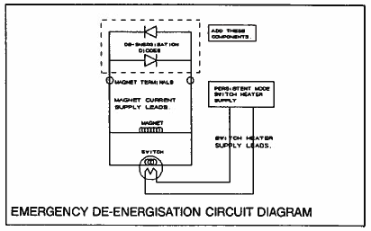
2.14 Magnet and Power Supply Problem Diagnosis
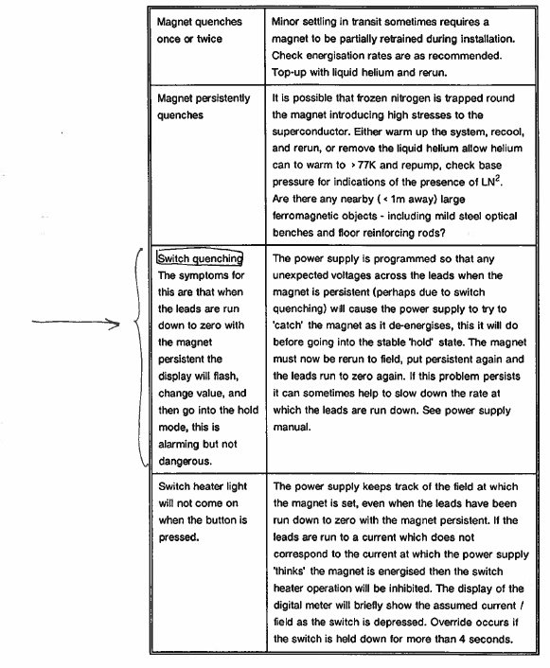

2.15 Magnet Electrical Access
Single current terminals or coaxial pairs are provided on the cryostat for attachment of room temperature current leads. Internally the current leads take the form of brass tubes shunted at their lower end by superconducting wire and cooled by helium gas from the main reservoir of liquid helium.
Current terminal pairs are wired as follows:
Centre or red terminal = +ve = start of magnet
Outer or black terminal = -ve = end of magnet
IMPORTANT: On no occasion should the current leads inside the cryostat be modified or any electrical connectors be unscrewed or removed. Serious damage to the magnet may result.
The magnet temperature and lambda point refrigerator performance (it fitted) are generally monitored with Allen-Bradley carbon resistors. An appropriate ten pin electrical seal is provided on the cryostat OVC, service neck or magnet support plate.
The superconducting switch heater will also be wired to a ten pin electrical seal.
2.16 Independent Shims and Current Settings.
The independent shim set is provided on the magnet to achieve a higher level of field homogeneity than is possible by using only series connected shims (generally it is used to achieve 1 part in 10⁶ homogeneity over 10mm dsv from a basic magnet with a nominal homogeneity of 1 part in 10⁵). If the experiment being performed is based on NMR signals then it will be possible for on-site shimming to be performed which would further optimise the field homogeneity eliminating any small variations caused by nearby pumps, structural steel etc.
Basic magnet homogeneity;
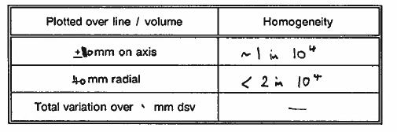
Shimmed magnet homogeneity;
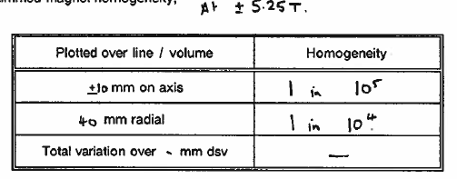
The independently energised superconducting shims should be set to the following currents using the 20 amp SPS10 shim power supply.
These nominal settings were found to be satisfactory on testing of the magnet system in the factory. Slight enhancements in the on site homogeneity may be possible by altering some of the currents slightly to eliminate the effects of the local ferromagnetic environment. This will be only possible if there is a suitable NMR signal available.
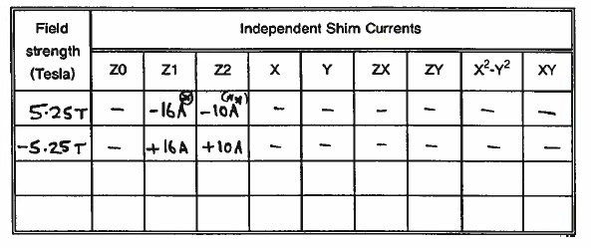
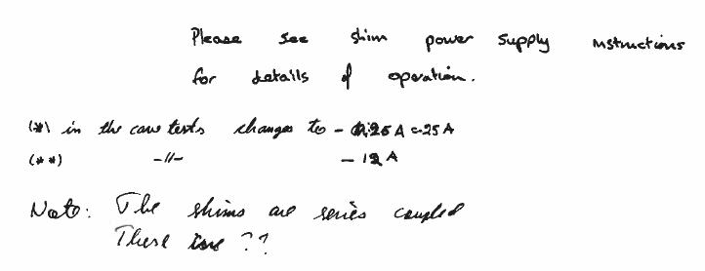

2.17 Independent Shim Wiring Diagrams
See ALD0023 supplied separately.

2.18 System Closedown
Temporary Closedown

If the system is to be left unattended for any length of time (eg over a weekend period) it is preferable, but not absolutely necessary to de-energise the magnet. However, the following precautions MUST be taken to ensure system safety.
- Ensure that the cryostat contains sufficient helium to last for the required period.
- Ensure that the nitrogen reservoir is full, and arrangements have been made to ensure topping up if necessary.
- Ensure that there is no chance of the helium or nitrogen exhaust ports becoming blocked or iced up. The helium exhaust should be connected to a helium recovery system or vented through a one-way valve.
In order to minimise helium consumption the lambda point fridge needle valve should be firmly closed and the fridge evacuated (if a lambda fridge is fitted).
Warming the system
Before warming the system, it is imperative that there is no trapped volume of gas or liquid within the cryostat. In particular the lambda point fridge exhaust port needle valves should be opened and linked to the main bath exhaust. (Alternatively the valve can be closed off and the fridge pumped out continually during the warming procedure).
Having adopted the above precautions, and with the magnet de-energised the system can simply be allowed to run out of liquid helium and nitrogen, and left to warm up. If a rapid warm up is desired either transfer the helium out of the cryostat into a transport dewar or insert the blowing out tube into the transfer tube entry port and gently pass DRY helium gas through it. This will boil-off the remaining liquid. Remove the liquid nitrogen by passing a stainless steel tube through one of the filler tubes and blocking off the other two fillers. This will pressurise the container and blow out the liquid.
Having removed all the cryogenic liquids the system can be warmed by softening the vacuum. Leave for 1 hour to let the magnet warm towards 77K.
Slowly allow 1 bladder full of DRY nitrogen gas into the OVC or admit it until approximately 10 millibar is reached, close off the evacuation valve. Non preferred method: With the vacuum valve closed, blow some helium gas into the pipe attached to the valve. Place a rubber bung on the end of the pipe, then open the valve and close it again. This technique ensures that only a small amount of helium gas enters the vacuum space, so that the warming up process is not too violent. Ensure that the relief valve is unobstructed. This technique is very effective, but afterwards great care must be taken to flush the helium out of the superinsulation. Do not under any circumstances attempt this method with vapour shielded dewars as they contain very large quantities of superinsulation making flushing difficult.
2.19 Typical Installation Requirements
The requirements below include items that may be purchased with Oxford Instruments spares kits.

PHYSICAL
Hoist or Crane | 1000kg minimum safe working load to allow lifting height of 3 metres.
Lifting sling and shackles | To suit eye bolts.
Trolley with wheels | Necessary it lifting equipment is not in laboratory. The system must be removable from the trolley for magnet running.
Wooden platform | Strong enough to stand the system on. It should be 25 cm high and is needed if it is suspected that the floor has steel reinforcing.
Personnel protection | Hazard warning signs, barriers and controlled entry systems as applicable to the environment.
Electricity supply | Single phase, several sockets needed.

TOOLS.
Spanners | Open ended. Metric.
Allen Keys | Metric Set
Screw Drivers | Various Sizes
Roll of Mylar Adhesive Tape
Roll of Aluminum Adhesive Tape
Tube of Vacuum Grease
Pair of Cotton Gloves
Boxes of Tissues
Indium Wire | 1 mm diameter (about 2 metres)
Rubber Bladders | 2 needed
Hot Air Gun / Electrical Soldering Iron – 75 Watts / Digital Multimeter
Rubber and Plastic Tubing | 0.375 ins (9.6 mm) bore diameter. 10 metres required.

VACUUM DEVICES.
Oil mist filters | Fitted to all pump exhausts to eliminate possible carcinogenic vapours.
High Vacuum Pump | Ideally fitted with penning gauge, capable of evacuating to less than 10⁻⁶ mB. (Can be diffusion pump fitted with Nitrogen cold trap, or turbomolecular pump). Pumping port should be 50mm diameter minimum.
Leak Detector | For checking indium joints

CRYOGENIC VESSELS AND FITTINGS.
Liquid Nitrogen | In self pressurising dewar. (300 litres typically)
Liquid Helium | In self pressurising dewar. (300 litres typically)
Helium gas | For flushing system. Can use gas for storage dewar or from a gas cylinder.
Helium Transfer Tube | Oxford Instruments standard diameter is 0.375 ins (9.6 mm).
Laboratory Clamps | To suit rubber tube.

Vacuum Fittings:
NW10 Clamps, "O" Ring Carriers, Christmas tree fitting,
NW25 Valves ( Edwards Speedivac recommended ),
NW25 Clamps, "O" Ring Carriers, Tees, Elbow, Christmas Tree fitting,
NW25/10 Adaptor
NW40 Clamp, "O" Ring Carrier, NW40/25 Adaptor
Pumping Lines NW25 each end, 2.5 metres long, 20 mm bore.

2.20 Assembling and Dismantling the System
Initial assembly will be done by an Oxford Instruments technician. It is important that the system is treated with respect, this is particularly important when moving the system.
Moving the system any appreciable distances ie to a new laboratory on a different floor of the building or to a new building should be done with the transit packing in position. It is highly recommended that this is done by an Oxford Instruments technician.
Brief Initial assembly (installation).
- The cryostat will arrive at the customer's site with internal packing to prevent transit damage to the delicate internal tubes etc. The first job is to remove the internal packing, support the cryostat top plate, on a crane using the lifting eyes on the top flange, unscrew the bolts holding the magnet OVC tail in position, carefully remove the OVC tail, taking care as it is heavy.
- The same should now be done with the tail radiation shield, packing pieces (usually marked red) will be found between the helium can and the nitrogen shield and between the nitrogen shield and the OVC. All these packing pieces should now be removed so that there is no connections visible between the OVC, nitrogen shield or helium can.
- The tails are now refitted, care must be taken to ensure that the radiation shields do not touch the magnet can or OVC. Radial and axial location is provided with the screws provided.

Disassembly.
- With the cryostat at room temperature fill the sample spaces with dry nitrogen gas or dry air, then fill the O.V.C. (outer vacuum can) with the same gas, slowly.
- Disconnect all wiring from the top of the cryostat.
- Disassembly is now the reverse of the procedure for assembly above.
If any problems are encountered please telephone the Oxford Instruments Agent's service department or Oxford Instruments directly.
2.21 System Wiring Diagram
See ALD0023 supplied separately.

SECTION 3- TEST RESULTS
3.1 Magnet Test Results
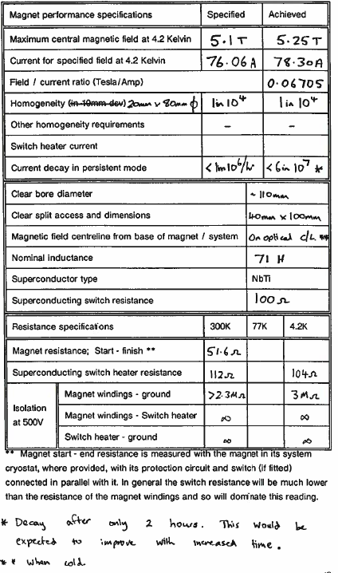
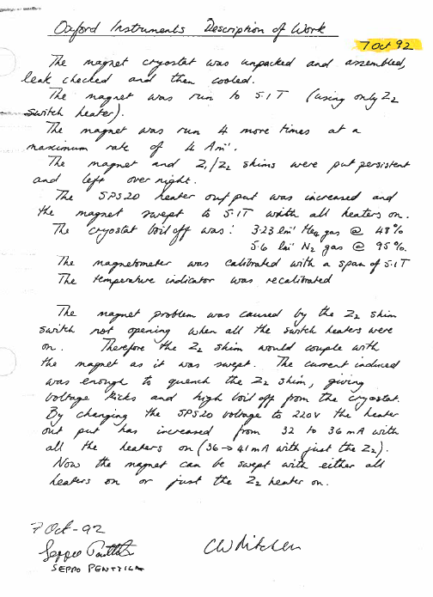
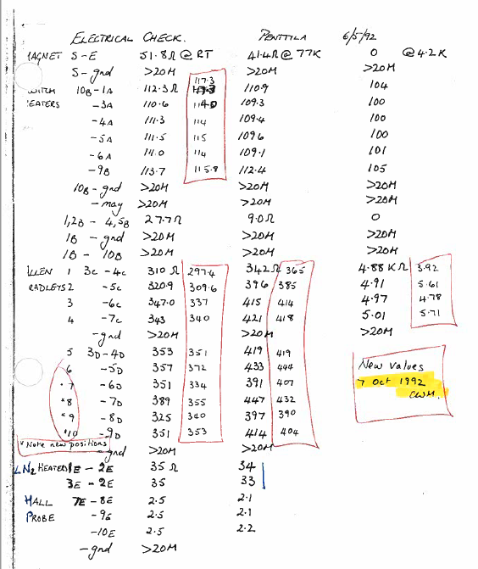
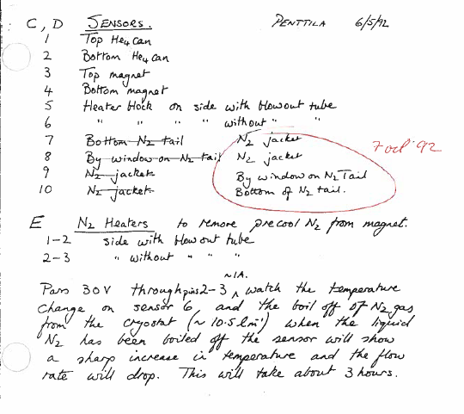
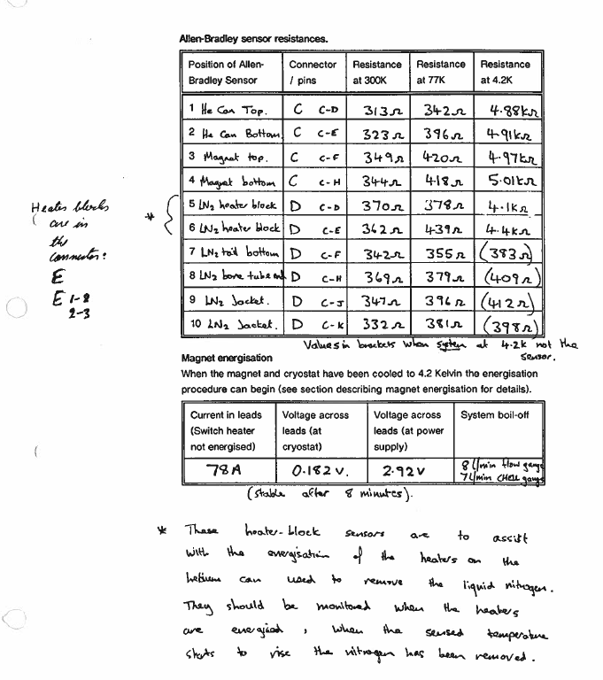
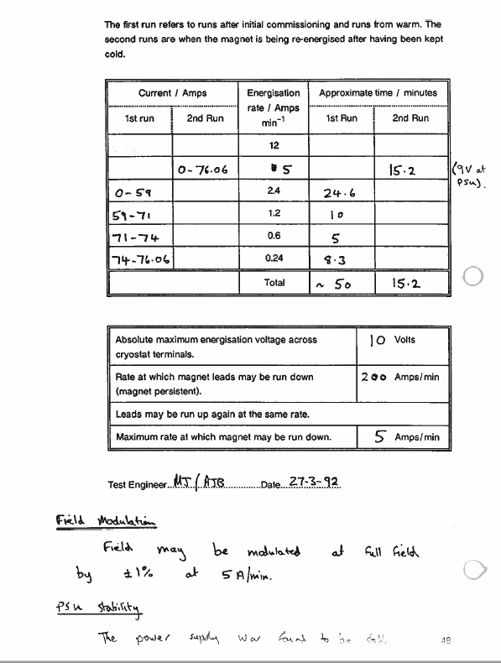
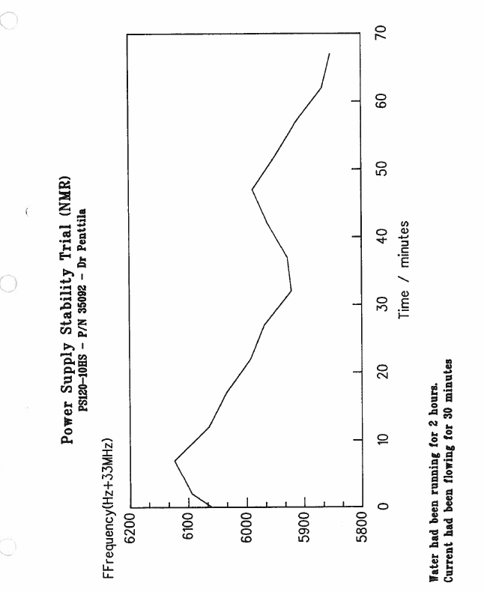
3.2 Cryostat Test Results
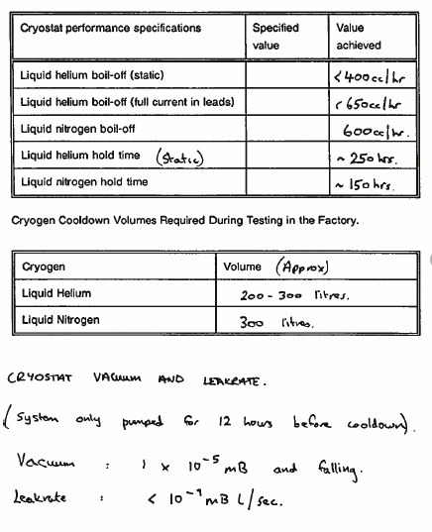
3.3 Field Profile
The magnet field to current ratio was measured with a Hall probe in a test cryostat which contains a set of room temperature insert tails. The Hall probe is calibrated against an NMR probe in an NMR magnet to ensure the accuracy of the measurements (an NMR probe being accurate to at least 1 x 10⁻⁶ while the Hall probe is only accurate to at best 1 x 10⁻⁴). (Magnets < 1 x 10⁻⁵ homogeneity in a 10mm dsv are plotted exclusively by NMR probe).
The predicted field plots obtained are shown overleaf. It should be noted that the 'distance along the axis' is relative to the test cryostat not the magnet, the actual field centre is given on the magnet specification page.
3.4 Field Plots
Plotting frequency = 33.447 MHz
Data points are in Hz.

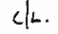
Circular planes plotted at 47.1 cm, 48.1 cm, 49.1 cm.
i.e. -1, 0, +1 cm relative to

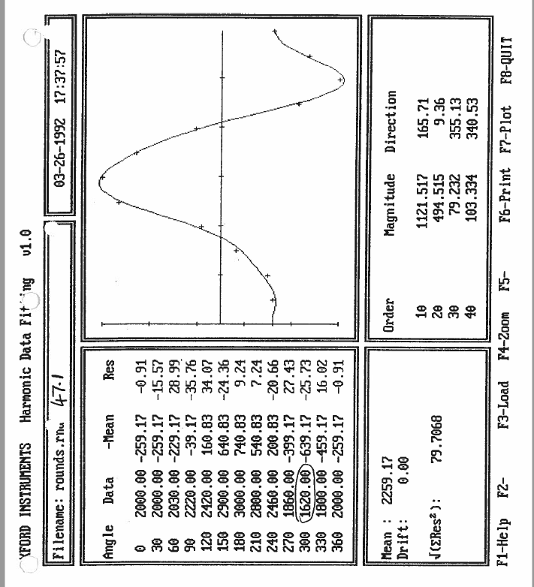
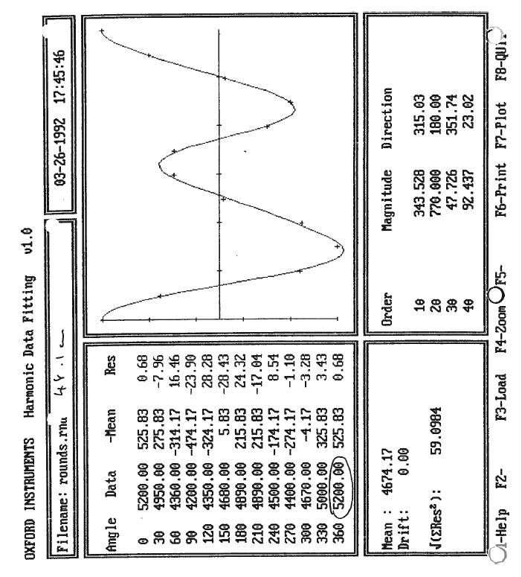
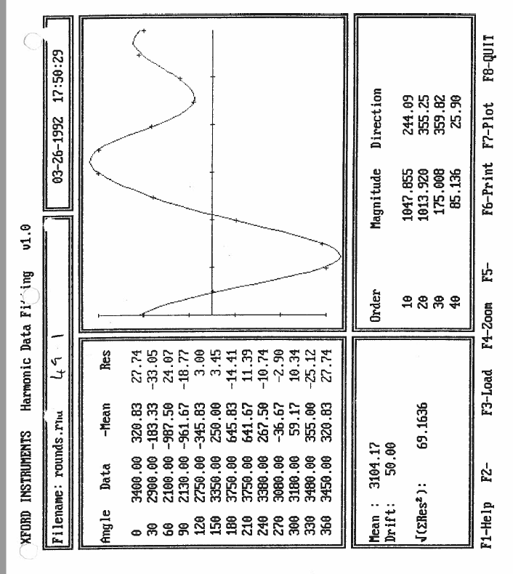
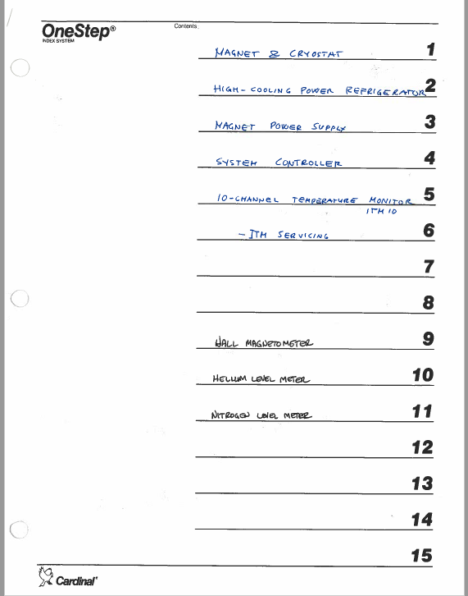

There was an arrow sketched in, pointing to this option
Another arrow to the first two lines.

